SUBJECT: | Btec DIT |  |  | YEAR: | 10 | 
TOPIC: | Component 1 – Creating User Interfaces |  |  | SEMESTER: | 2
WORD REVOLUTION
User Interface | The way a user interacts with a computer system or software.
GUI | Graphical User Interface – uses windows, icons, menus, and pointers.
Menu | A list of options or commands presented to the user.
Navigation | How users move through an interface or system.
Accessibility | Design features that make interfaces usable for people with disabilities.
Layout | The arrangement of elements on a screen or page.
Feedback | Responses given by the system to user actions (e.g. error messages).
Consistency | Keeping design elements uniform across the interface for ease of use.
Usability | How easy and efficient an interface is for users to operate.
Touchscreen | A sensor-based interface that responds to touch input.
Voice Control | An interface that allows users to interact using spoken commands.
Icon | A small graphic used to represent a command, file, or function.
Responsiveness | How quickly and smoothly an interface reacts to user input.
Wire frame | Basis design drawing to show layout, structure, inputs and outputs
What will I study in this topic? | In Component 1 we explore what is a USER INTERFACE (UI), the different types of UIs and how these are tailored to meet different user. We will learn about the varying types of needs of a user both from a physical and accessible standpoint but also from a social angle exploring the need to account for previous experiences and technical knowledge
What will I be able to do by the end of this topic? | By the end of Component 1, you will be able to confidently describe different types of user interfaces. You’ll understand how these interfaces are designed to meet the needs of different users, including those with accessibility requirements, and how design principles contribute to a positive user experience. You’ll also be able to design a real-world interfaces to meet user needs, giving you the skills to begin planning and designing your own digital solutions in future components.
Powerful Knowledge |  |  | Powerful Knowledge
What is a User Interface?  A user interface (UI) is a channel between human and computer interaction – the space where a user will interact with a computer or machine to complete tasks.  UI are made up of Hardware and Software features:  Hardware – Accessibility features (text to speech, high contrast mode, font sizing, etc…)  Software – Visual (windows, icons, menus and pointers), Sound (speech recognition) |  |  | What are the different types of UIs?  Command Line – Text-based, specialist knowledge required to use it  Menu – Simplistic design, linear or form based. Tends to have limited options  GUI (Graphical User Interface)– Simple drag and drop format. Use of windows, pointers and menus.  Speech – reduces need for technical knowledge  Sensor – constantly monitoring the environment around it (plant feeder, automatic doors)
Powerful Knowledge |  |  | 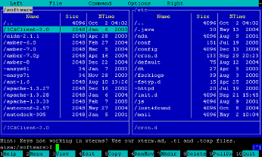  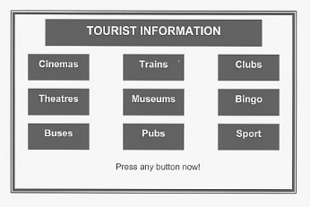  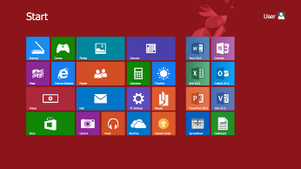  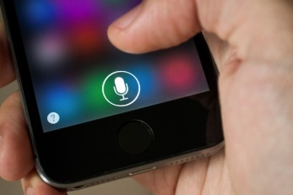
Factors that affect the choice of UIs?
Response time – how quickly it performs and responses to the user action
Ease of Use – How intuitive is it & simple to perform tasks
User Requirement – Does it do what it should do?
User Experience – What technical level does the user have?
Accessibility – Are all individual needs being considered in the design?

SUBJECT: | Btec DIT |  |  | YEAR: | 10
TOPIC: | Component 1 – Creating User Interfaces |  |  | SEMESTER: | 2
Assessment Task 1 – Creating a Project Proposal and Planning Project Timescales
Key Questions: | What is a project proposal and what should it cover?  What are requirements and constraints of a project?  Who is the audience of the project?  What are project timescales and how do we show this?  What are milestones?  Are all tasks dependent on the one before? |  | 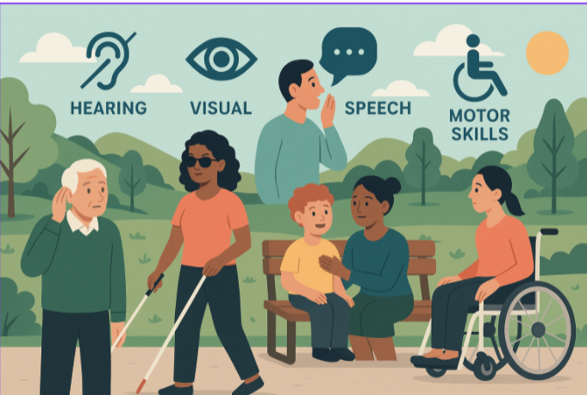
Powerful Knowledge |  |  |  | 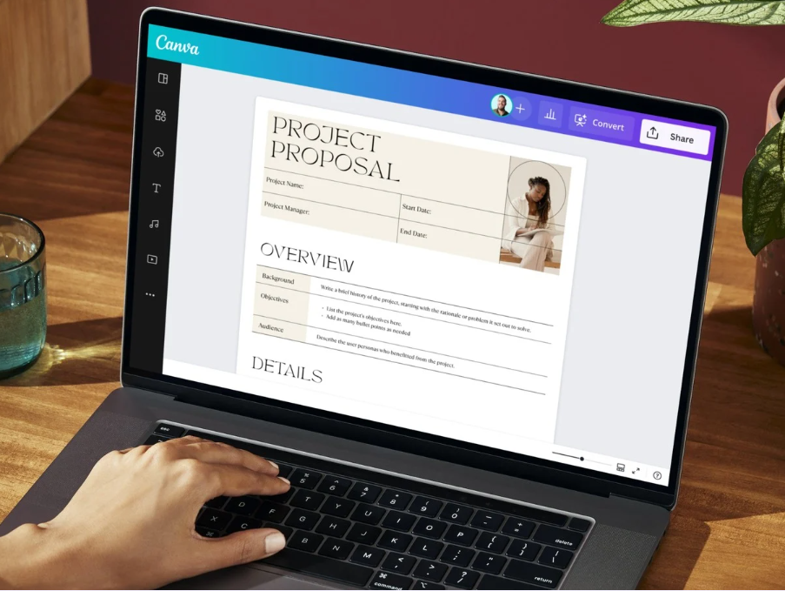
Project Proposal
The project proposal is a key document in Component 1 as it is used to show understanding of the assignment brief you have been given.
Purpose and audience – what is the actual purpose of the UI? Is it to provide awareness, information or safety instructions? Who is the target audience? Children, adults, families, business type, etc…
Project Requirements – What does the project client want from the UI? What should it achieve? How will you measure its success?
Accessibility Requirements – Hearing, visual, speech, cognitive and motor skills should all be considered in the design to meet every user’s needs
Constraints – What are the limitations on the project? Time pressures, resources, each task dependent on another task, security of the data

Powerful Knowledge |  |  |  | 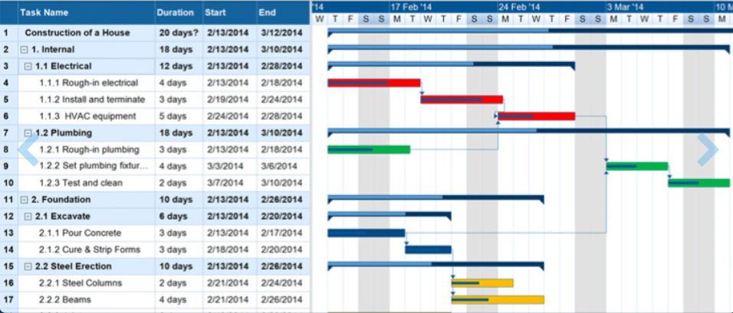
What is a Gantt Chart?
A Gantt Chart is a list of tasks that together show the length of time to complete a project. An example of one is to the right of this text.
Why use Gantt Chart?
- Each task in the task list is assigned a length of time it will take to complete (the timescale)
- We also identify the task dependencies (what each tasks required to be completed before it can start)
- This can be then mapped out on a grid with each row being a task, and each column being a period of time
- Resources and staff can be added to the chart to help manage what will be needed and when
- Clear milestones can be highlighted where key events have to occur before the project can continue further
- Colour coding and the use of a key makes a good visual representation of the project that can be tracked

SUBJECT: | Btec DIT |  |  | YEAR: | 10
TOPIC: | Component 1 – Creating User Interfaces |  |  | SEMESTER: | 2
Assessment Task 2 – Interface Designs
Key Questions: | What is the purpose of a wireframe storyboard design?  What should one look like?  What should be included on one?  What should not be included?  How can you ensure it meets the client’s requirements? |  |  | 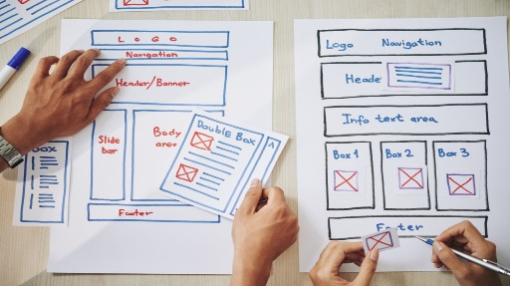
Powerful Knowledge |  |  | 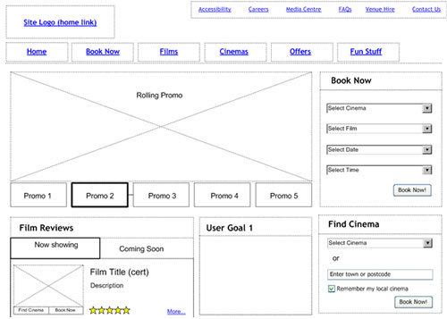
What is a Wireframe diagram?
A wireframe diagram is the skeleton blueprint of what your intended website or interface will look like.
It is not designed to be colourful or to include assets and images on it, that happens at a later stage
The wireframe is designed to show the following:
- Basic layout of all the elements on the page
- Indication of any interactive features such as buttons and hyperlinks
- An indication of what font will be used (serif, sans serif) and the font size based on heading levels (main, sub)
- An indication of colours to be used for the background and font colours
- The position of text and images with brief descriptions of what will be included on the screen (not the actual words or images though)
- How forms and slides may link to other forms and slides

Powerful Knowledge |  |  | 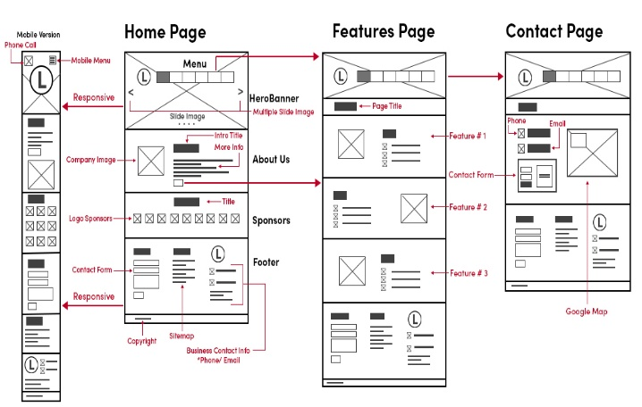
Why do we need a wireframe when we could save time and go straight into designing the interface?
It’s a good question but in real life situations it is important to make sure you get the interface correct the first time.
To do this you must:
- Talk with the client to understand their needs and what they expect from this interface
- Find out who the audience is and how this might influence design choices
- Produce a wireframe to get a better understanding of what this may look like.
- Clearly show the inputs, interactivity and outputs that will be included
- Talk to the client and show these designs
- Be able to give justification as to why these designs match what they client has asked for
- Get approval to go ahead.
- If someone is ill others can still continue with the interface by following these designs

SUBJECT: | Btec DIT |  |  | YEAR: | 10
TOPIC: | Component 1 – Creating User Interfaces |  |  | SEMESTER: | 2
Assessment Task 3 – The User Interface Prototype
Key Questions: | What do we mean by the word prototype?  What determines success of a prototype?  What should be included?  What do we mean by navigation?  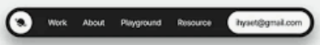  What resources or assets should be on there? | 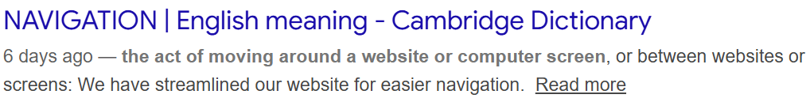
Powerful Knowledge |  |  |  | 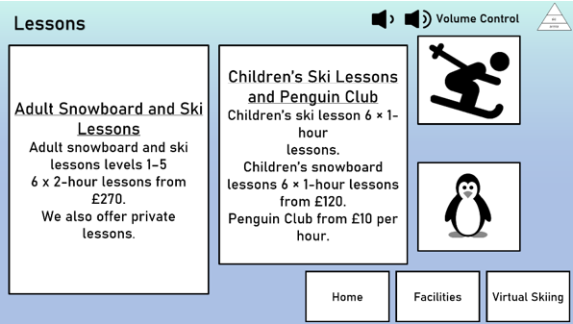
Making a prototype
A prototype is a simple version of an end product to show how a functioning model may look and perform
A prototype does not have to be web-based. At this stage it should successfully show how buttons and links will interact and how the navigation will work. For this reason, presentation software such as PowerPoint is acceptable at showing this.
Accessibility features
The prototype should be able to give a good account of how different types of users will be catered for. Features may include light/dark mode, audio description or volume controls. Buttons may have hover over glow to indicate they are links, ALT text may be used in conjunction with Text-to-Speech. Videos may include subtitles.
Navigation Features
Navigation around the site should be intuitive and seamless. Obvious buttons, navigations bars, drop down menus and consistent design all help

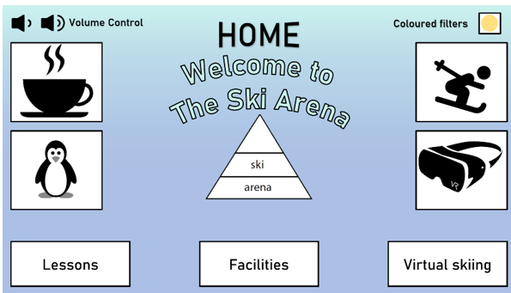  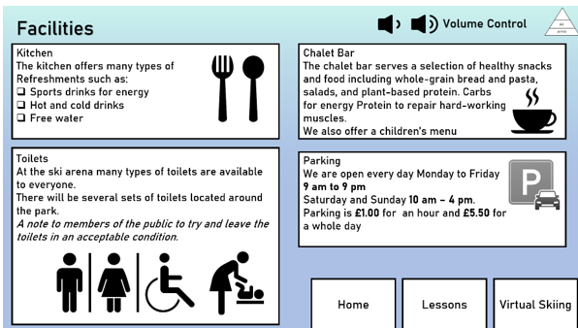 |  |  |  | 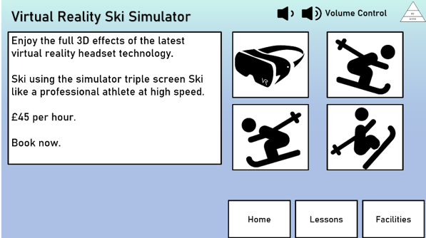

SUBJECT: | Btec DIT |  |  | YEAR: | 10
TOPIC: | Component 1 – Creating User Interfaces |  |  | SEMESTER: | 2
Assessment Task 4 – The User Interface Review
Key Questions: | What do we mean by a review?  How do we measure success?  What do we mean by design principles?  How do we take into account of the user’s experience?  Do I need to find improvements? |  |  | 
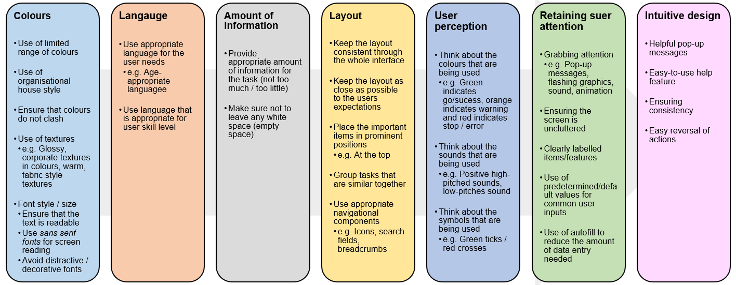 |  |  | 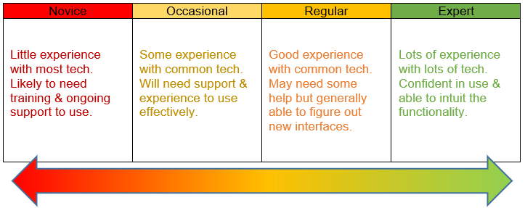  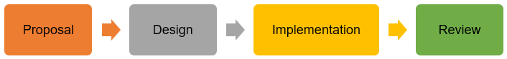  Skill Levels of the User
Powerful Knowledge |  |  | 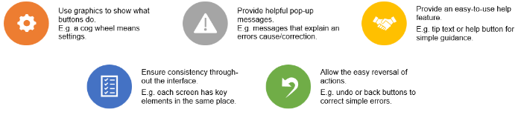
What is a review?
The is the final part in any project and is where you look back at the original project proposals (from Task 1) and compare them to the finish interface to see how well they have matched the client’s needs.
The review will critically evaluate the interface against the following criteria:
- Original user requirements as stated in Task 1
- Ease of use (See Skill Levels Table)
- Design principles used (See table above)
- Accessibility features used (See table to the right)
Improvements will always be mentioned and are best framed as, “if I did this again, I would do this differently because…”

