SUBJECT: | Health & Social Care |  |  | YEAR: | 10 | 
TOPIC: | R033 |  |  | SEMESTER: | 2
WORD REVOLUTION
Life Stages | Distinct phases of human development (e.g., early childhood, adolescence, adulthood).
Growth & Development | Growth- physical increase. Development- intellectual, emotional, social progression.
PIES | Acronym for the four development areas: Physical, Intellectual, Emotional, Social.
Milestones | Typical developmental achievements reached at certain life stages (e.g., walking)
Expected life events | Significant events that usually happen as part of life’s natural progression (e.g., starting school, retirement).
Unexpected life events | Unplanned or sudden changes (e.g., bereavement, job loss, serious illness).
Source of support | Means of help, such as formal services, informal support and charities.
Practitioner roles | The responsibilities of trained professionals in providing tailored support and services.
Informal care giver | Unpaid individuals—often family or friends—who support persons through life events.
Needs assessment | Identifying the specific needs of an individual based on their experiences and impacts from life events.
Recommend support | Suggesting appropriate interventions or resources to meet identified needs.
Layers of support | Individuals may benefit from multiple types of support (formal, informal, community resources)
Resilience | The ability to recover and adapt positively after facing challenges, stress, or unexpected events.
Self-concept | How a person sees and values themselves, including their self-esteem and self-image.
What will I study in this topic? | - Life stages and PIES development  - Factors affecting growth and development  - Expected and unexpected life events  - Impacts of life events on health and wellbeing  - Types of support (formal, informal, voluntary, professional)  - Roles of practitioners and caregivers in helping individuals cope
What will I be able to do by the end of this topic? | - Describe life stages and PIES development  - Explain factors affecting development  - Discuss impacts of life events  - Apply knowledge to case studies and suggest suitable support options  - Evaluate effectiveness of support
Task 1 - Case Study (Chosen Individual) |  |  | Task 2a – Interview (real individual)
- Pick one individual (famous or known personally) to study.  - Keep their details anonymous.  - Use them to explore life stages, development, and factors.  - Each student should choose a different person. |  |  | - Choose someone willing to be interviewed about their life events.  - Get consent and follow safeguarding and GDPR rules.  - Provide evidence of the interview (e.g., notes, photos, audio, authentication form).  - Keep all personal info confidential and anonymised.  - Suitable individuals: family, friends, or peers.
Task 2b – Research and recommendations |  |  | 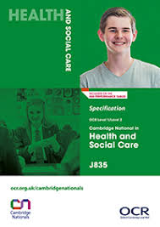
- Carry out independent research (not just quick searches).
- Investigate support options from different perspectives.
- Apply person-centred values (from R032) when suggesting support.
- Each student’s work should be individual, not identical.
- No templates provided by teachers.

SUBJECT: | Health & Social Care |  |  | YEAR: | 10
TOPIC: | R033 |  |  | SEMESTER: | 2
Key Questions: | - What are the main life stages and how does PIES development change across them?  - What factors can affect an individual’s growth and development throughout life?  - What are examples of expected and unexpected life events, and how can they impact PIES and wellbeing?  - What different types of support (formal, informal, charities) are available, and how do they meet individual needs?  - How can practitioners and caregivers apply person-centred values when supporting someone through life events?
Curriculum Connections: | - Science- Links to human growth and development, health, and the effects of illness or lifestyle on the body.  - PD- Connects with life events, wellbeing, relationships, and support networks in society.  - English- Builds skills in research, interviews, report writing, and evaluating information.  - PE- Supports understanding of how activity impacts PIES development, especially physical and emotional wellbeing.
Topic area 1 key areas- |  |  | 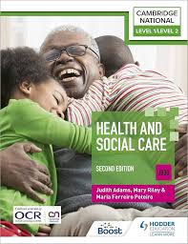
Life stages: childhood (4–10), adolescence (11–18), young adulthood (19–45), middle adulthood (46–65), older adulthood (65+).
PIES development at each stage:
- Physical: motor skills, puberty, menopause, ageing.
- Intellectual: language, problem-solving, decision-making, decline with age.
- Emotional: bonding, attachments, independence, self-image, love, affection.
- Social: relationships, social skills, responsibilities.
Factors affecting growth & development: physical (health, illness), social (family, friends), emotional (self-esteem, resilience), economic (income), cultural (beliefs, traditions), environmental (housing, pollution).

Topic area 2 key areas- |  |  | 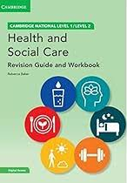
Types of life events: physical (illness, accident, puberty, menopause), relationship changes (divorce, bereavement, parenthood), life circumstances (school, redundancy, retirement, imprisonment).
Impacts: physical (illness, mobility, appearance), intellectual (learning, adapting, impairment), emotional (grief, stress, self-esteem), social (relationships, lifestyle), financial (income/costs).
Identifying needs: match impacts to support, e.g., stress → mental health help; income loss → financial advice; learning difficulties → specialist support.

SUBJECT: | Health & Social Care |  |  | YEAR: | 10
TOPIC: | R033 |  |  | SEMESTER: | 2
Topic area 3 key areas-
- Types of support:
  - Formal: hospitals, care homes, hospices, rehabilitation, day centres, Informal: family, friends, community, religion/culture, Charities: Mind, Age UK, Cruse, Relate, Gingerbread, specialist charities.
- Roles of support:
  - Practitioners: GPs, nurses, social workers, counsellors, physiotherapists, dieticians.
  - Informal carers: family/friends giving practical or emotional help.
- How practitioners meet needs: independence, medical/mental health care, respite, financial help, advice, coordinated care.
- Research & recommend support:
  - Match support to individual needs (statutory vs private, location, cost, availability).
  - Justify choices and apply person-centred values (respect, dignity, individuality, choice).

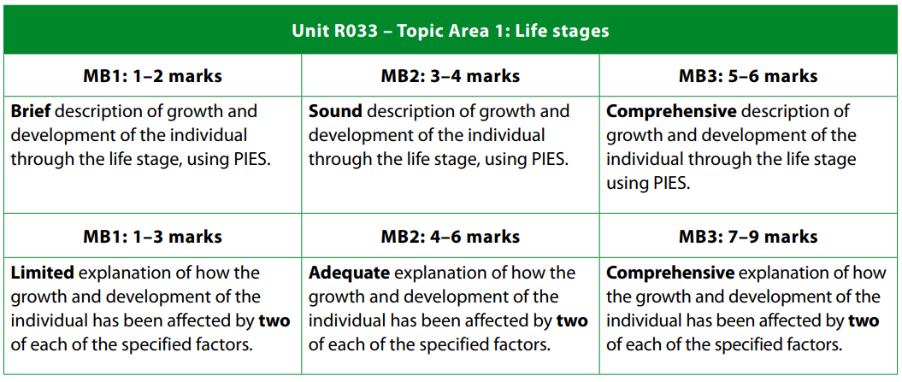 |  | 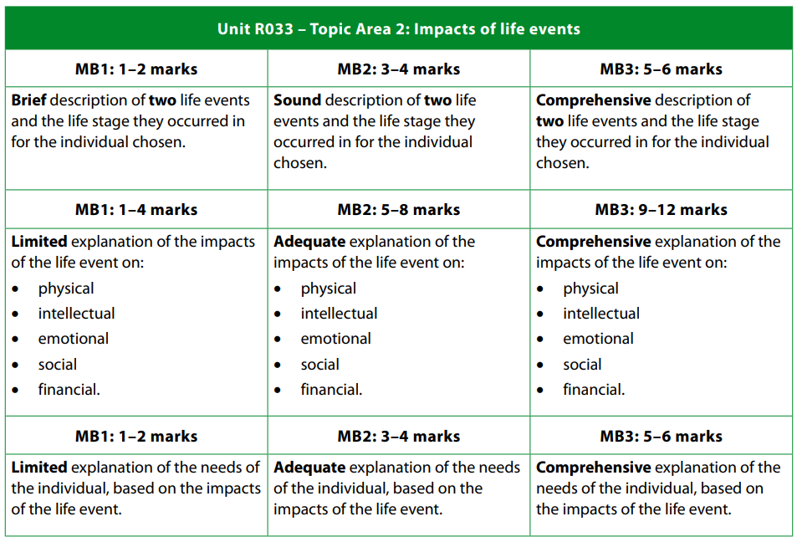
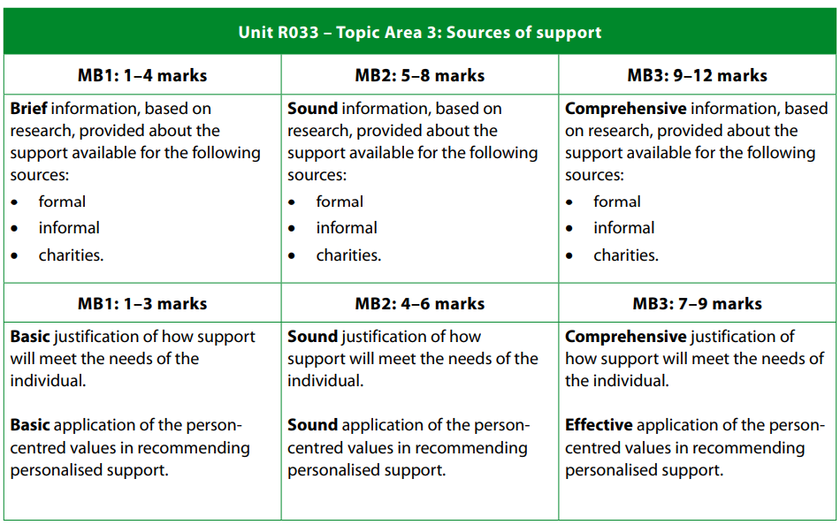

SUBJECT: | Health & Social Care |  |  | YEAR: | 10
TOPIC: | R033 |  |  | SEMESTER: | 2
How will I be assessed? | - Assessment type: Controlled assessment (set assignment by OCR).  - Weighting: Worth 50% of the qualification.  - Format: Students complete tasks based on a chosen individual and an interviewed individual.  - Evidence: Written reports, interview notes, research findings, and recommendations.  - Marking: Assessed by the teacher and moderated by OCR.
What to know to achieve top marks:
- Life stages & PIES: Describe each stage (childhood → older adulthood) and explain physical, intellectual, emotional, and social changes.
- Factors affecting development: Explain physical, social, emotional, economic, cultural, and environmental influences with examples.
- Life events & impacts: Include expected and unexpected events; explain effects on PIES and finances.
- Identifying needs: Link impacts to individual needs (e.g., stress → counselling; mobility issues → physiotherapy).
- Sources of support: Include formal, informal, and charity support; explain how it meets needs.
- Recommendations: Suggest personalised support, justify choices, and apply person-centred values.

Extra Nuggets! |  |  | Extra Nuggets!
- Cover all areas fully – include life stages, PIES development, factors, life events, impacts, needs, and sources of support.  - Use detail and examples – not just lists. Explain why and how things affect individuals, with clear case study links.  - Show analysis – go beyond description. Compare, explain impacts, and explore consequences of life events. |  |  | - Make recommendations – suggest support that is realistic, matched to individual needs, and justified.  - Apply person-centred values – show respect, individuality, choice, dignity, and independence in recommendations.  - Show clear organisation – well-structured report, logical flow, correct terminology, and professional style.
Further Reading and Other Resources |  |  | Recall Questions
- Cambridge National Level 1/2 Health and Social Care Student Book  - My Revision Notes: Cambridge National Level 1/2 Health and Social Care  - BBC Bitesize – Health and Social Care  - Mind Charity – Mental Health Support  - Age UK – Support for Older Adults |  |  | 1-What are the five main life stages and their corresponding age ranges?  2-List the four areas of PIES development and give one example of change in each.  3-Name three expected and three unexpected life events that can affect individuals.  4-Identify three types of support available and give an example of each.  5-What are person-centred values, and why are they important when supporting individuals?  6-What are the six factors that can affect growth and development?  7-Give two examples of how a life event can impact an individual’s emotional and social wellbeing.

