SUBJECT: | Computer Science |  |  | YEAR: | 10 | 
TOPIC: | Algorithms & Flowcharts |  |  | SEMESTER: | 2
WORD REVOLUTION
Algorithm | A step-by-step set of instructions used to solve a problem.
Computational Thinking | Methods such as decomposition, abstraction and algorithmic thinking used to approach problems logically.
Pseudocode | A structured way of describing an algorithm that looks like code but isn’t tied to a real programming language.
Variable | A named memory location whose value can change during program execution.
Constant | A named value that does not change while the program runs.
Sequence | A series of instructions carried out in order.
Selection | A decision in a program (e.g. IF statements).
Iteration | Repeating instructions (loops), e.g. FOR, WHILE.
Boolean Operator | Operators such as AND, OR, NOT used in conditions and logic gates.
Translator | Software that converts source doe into machine code.
IDE (Integrated Development Environment) | A software environment that provides tools such as an editor, error diagnostics, and a run-time environment.
What will I study in this topic? |  | In this topic, you will build your understanding of how computational problems are solved, and how software is written, tested, and executed. You will explore:  - Algorithms: designing step-by-step solutions using pseudocode, flowcharts, trace tables and decomposition.  - Programming Fundamentals: variables, data types, selection, iteration, file handling, arrays, and subprograms  - Boolean Logic: logic gates, truth tables and combining Boolean expressions.  - Network Security: threats, attacks and security measures
What will I be able to do by the end of this topic? |  | By the end of this topic, you will be able to: Break down problems using abstraction and decomposition. Design algorithms using pseudocode and flowcharts and refine them using trace tables. Use key programming constructs confidently (sequence, selection, iteration). Write programs using variables, data types, arrays, file handling, subprograms and operators. Identify and fix syntax and logic errors, and design effective test plans. Apply Boolean logic to complete truth tables and draw or interpret logic diagrams.
Algorithms
Computational Thinking |  |  | Designing Algorithms |  |  |  |  | Searching & Sorting Algorithms
Computational Thinking  Abstraction: removing unnecessary details.  Decomposition: breaking problems into smaller parts.  Algorithmic Thinking: forming logical, repeatable steps |  |  | Identify inputs, processes and outputs.  Use structure diagrams, pseudocode or flowcharts.  Use trace tables to track variable changes.  Common errors include syntax (breaking rules) and logic (wrong result) |  |  |  |  | Linear search checks every item sequentially, works on unsorted data (O(n)), and is simple but slow for large lists.  Binary search repeatedly halves the search space by checking the middle element, requires sorted data (O(log n)), and is much faster for large datasets but more complex to implement.
Flowchart Symbols
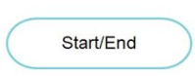 | 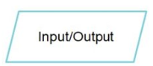 |  |  |  |  |  | 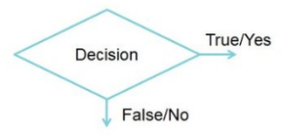

SUBJECT: | Computer Science |  |  | YEAR: | 10
TOPIC: | Paper 1/2 content |  |  | SEMESTER: | 1
Key Questions: |  | - How do we design effective algorithms logically and efficiently?  - How do programming constructs help build working software?  - Why is testing essential for producing robust programs?  - How do Boolean logic and logic gates underpin decision‑making in computing?  - How do different programming languages and tools affect software development?  - What threats exist to digital systems, and how can these be reduced?  - How do operating systems and utilities manage and maintain hardware and data?
Curriculum Connections: |  | This unit develops your computational thinking ability and prepares you for advanced programming challenges in later GCSE topics. It bridges with:  - KS3 programming foundations  - GCSE Paper 2 problem-solving tasks  - A-Level Computer Science (algorithms, logic, systems)
What is logic? |  |  | 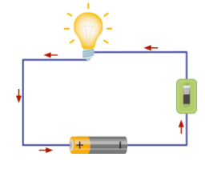 |  | Logic Gates & Truth Tables
Computers and computer programs are all about solving problems. To solve problems, we need to understand the idea of logic – what happens when something and/or something else happens. | If you look at the lights in your classroom, they can be either ON or OFF.  Your lights are controlled by a switch on the wall. If the switch is ON, the lights are ON. If the switch is OFF, the lights are OFF. There is no such concept as ‘sort of on’.  This works by closing an electrical circuit, allowing current to flow to the lights, when you press a switch. |  |  |  | 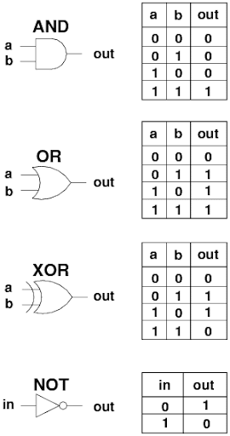
How does binary work within logic gates? (Link to Unit 2: Data Representation)
Binary is the language that logic gates understand. Each logic gate works with inputs and outputs that are either 0 (off/false) or 1 (on/true), which are the two values in the binary system. For example, an AND gate will only output 1 if both its binary inputs are 1, while an OR gate outputs 1 if at least one input is 1. So, binary values flow through these gates, and the gates apply logical rules to decide the output. This is how computers process decisions at the most basic level!

Binary and logic gates are the foundation of all computer operations. When you combine multiple gates, you can build circuits that perform more complex tasks, like adding numbers or making decisions. For example, a computer processor uses millions of these gates to carry out instructions, all based on binary signals. This means that every calculation, from simple addition to running a game, starts with binary values being processed through logic gates according to logical rules.

SUBJECT: | Computer Science |  |  | YEAR: | 10
TOPIC: | Boolean Logic |  |  | SEMESTER: | 2

SUBJECT: | Computer Science |  |  | YEAR: | 10
TOPIC: | Network Security & System Software |  |  | SEMESTER: | 2
Network Threats
Threat | Description |  |  |  | How to protect against it?
Malware (Viruses, Worms & Trojans) | Malicious software designed to damage systems, steal data or give attackers access. |  |  |  | Install and update anti-malware software; keep systems patched; avoid downloading unknown files; use firewalls.
Phishing | Fake emails, texts or calls pretending to be legitimate to steal personal information. |  |  |  | Check sender details; avoid clicking unknown links; use spam filters; never share personal info via email.
Denial of Service (DoS/DDoS) | Flooding a server with traffic so it slows or crashes. |  |  |  | Use firewalls and intrusion detection systems; rate-limiting; DDoS protection services.
Man-in-the-Middle Attack (MITM) | Attacker intercepts communication between user and server, stealing or altering data. |  |  |  | Use encrypted connections (HTTPS); avoid public Wi-Fi; use VPNs; ensure certificates are valid.
Social Engineering | Psychological manipulation to trick people into revealing information. |  |  |  | Educate users; verify identities; never share passwords; be cautious of unexpected requests.
Ransomware | Malware that locks or encrypts data and demands a ransom for access. |  |  |  | Maintain regular backups; avoid suspicious emails/links; keep systems updated; use anti-malware.
What is an Operating System? |  |  | Roles of the Operating System |  |  |  | Types of Operating Systems
Operating systems are essential system software that manage a computer’s hardware, software resources and users, providing the platform on which application software runs. System software includes operating systems, utility programs and translators, all of which support the smooth running of applications. Examples of widely used operating systems include Microsoft Windows and the earlier MS-DOS, Apple’s macOS, Google’s Android and ChromeOS, and Linux, each offering different features and interfaces but fulfilling the same core purpose of enabling users and applications to interact effectively with computer hardware. |  |  | 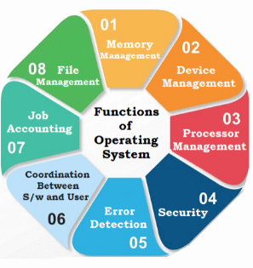 |  |  |  | Operating systems are the core software that manage a computer’s hardware and allow applications to run by controlling memory, files, devices and user interactions. Utility programs support the operating system by performing maintenance tasks such as file compression, virus scanning, defragmentation and system cleanup, helping keep the computer running efficiently. Program translators convert code written by programmers in high-level or assembly languages into machine code that the processor can understand, enabling software to be executed correctly on the system.
Types of User Interfaces
Command Line Interface | Menu-Based Interface | Graphical User Interface (GUI) |  |  |  | Sensor Based Interface |  | Voice-Activated Interface
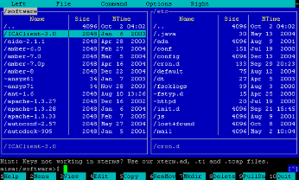 | 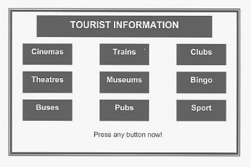 | 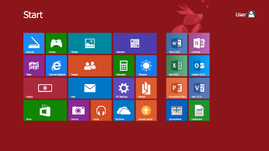 |  |  |  |  |  | 

SUBJECT: | Computer Science |  |  | YEAR: | 10
TOPIC: | Programming Fundamentals |  |  | SEMESTER: | 2

Data Types
Integer | Real | Boolean | String | Casting
Whole Number  Python Syntax: player_age = (15) | Decimal number. Also known as a float.  Python Syntax: player_height = (150.8) | True or False. | A sequence of characters which include letters, numbers & symbols.  Python Syntax: player_name = (“Zaphod”) | Changing the data type of a variable.  Python Syntax: int(34.2)

Comparison Operators |  |  | Arithmetic Operators |  |  | Length of a string/character position
== | Equal to |  | + | Addition |  | The length of a string can usually be determined using the len statement. This gives the length as an integer.  word = (“Computer”) word_length = (len(word))  It is possible to determine which character features at a position within a string as each character is numbered. Computers start counting at 0 so the first character is always 0.  word = (“Computer”) print (word[2]) #would print the character “m” as c = 0 and o = 1.
> | Greater Than |  | - | Subtraction
< | Less Than |  | * | Multiplication
!= | Not equal to |  | / | Division
>= | Greater than or equal to |  | ^ | Exponentiation (to the power of)
<= | Less than or equal to |  | MOD | Modulus
Concatenation |  |  | Sequence/Selection |  |  | Iteration
To concatenate strings means to join them to form another string – adding two strings together.  word = (“Computer”)  sentence = ( word + “Science”) #would add the two strings together to form one string which is “Computer Science” |  |  | Sequence: A set of instructions or lines of code that follow on one from another.  player_name = str(input(“Enter your name”) print (“Hello”, player_name)  Selection: A decision within a computer program when the program decides to move on based on the results of an event.  player_colour = int(input(“Press 1 for red, 2 for blue or 3 for green”)) if player_colour == 1: print (“You have selected red”)  elif player_colour == 2: print (“You have selected blue”)  elif player_colour == 3: print (“You have selected green”)  else: print (“You did not press 1,2 or 3”). |  |  | While Loop: The repetition of a block of statements within a program when the number of repeats is not known.  player_turns = 5 while player_turns >0:  print (“Player takes their turn”) player_turns = player_turns – 1  For Loop: The repetition of a block of statements within a program when the number of repeats is known.  for counter in range (0,10,1): print (counter)

