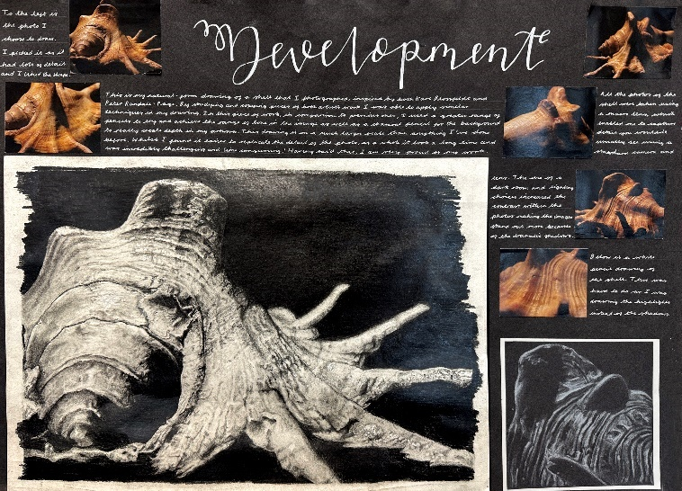
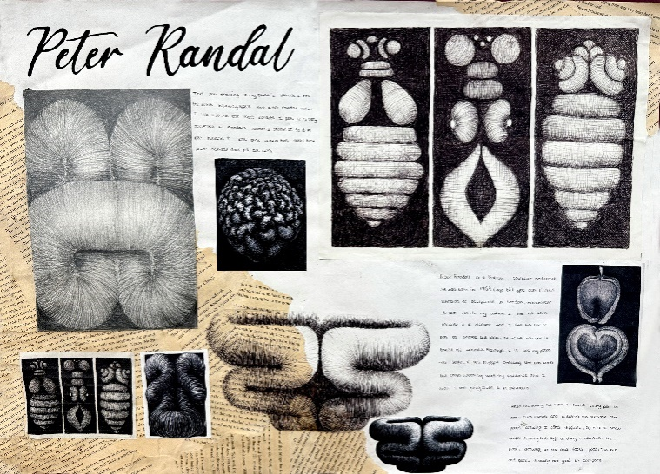
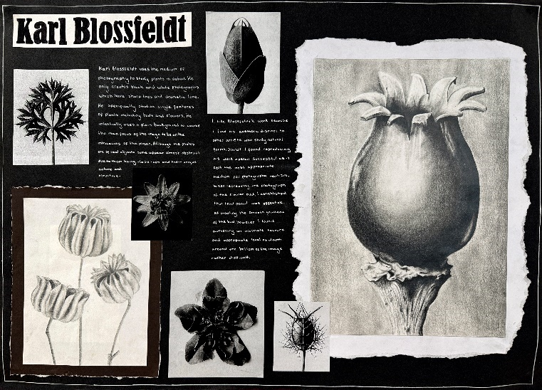
SUBJECT: | EDIT |  |  | YEAR: | EDIT | 
TOPIC: | EDIT |  |  | SEMESTER: | 1

SUBJECT: | Art & Design |  |  | YEAR: | 10
TOPIC: | Organic Structures: Pattern, Form & Texture |  |  | SEMESTER: | 2

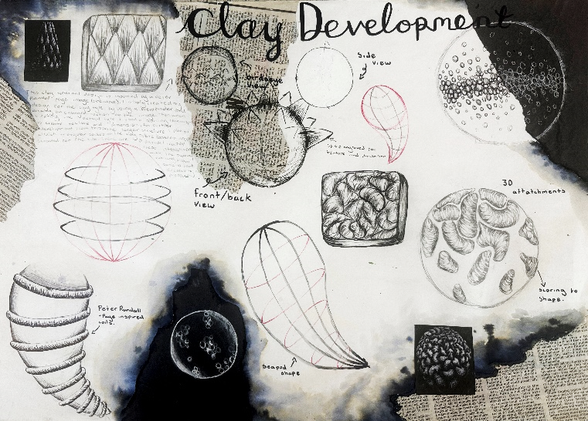
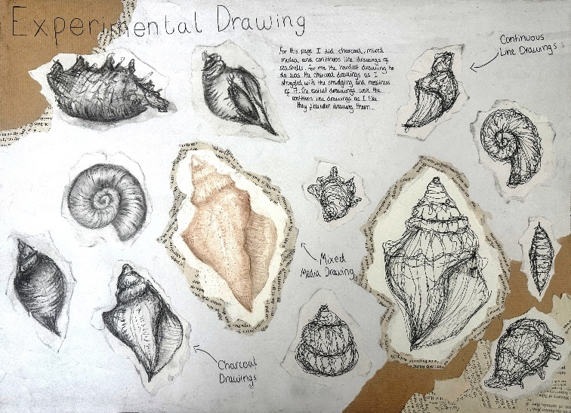
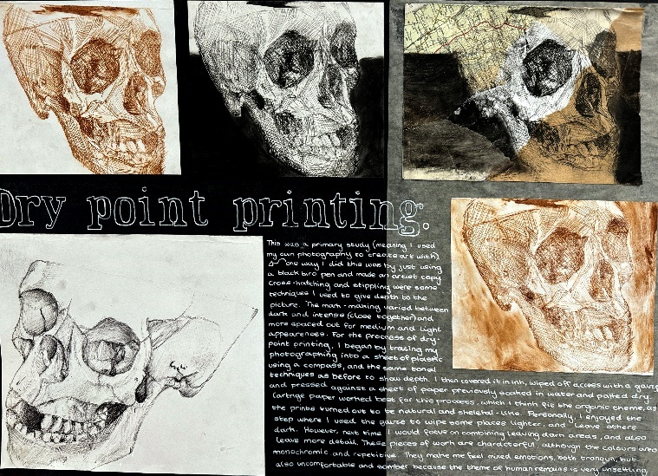

NATURAL FORMS MINOR PROJECT - GRADE 9 EXAMPLES AND GENERAL GUIDANCE
• Introduce the artist using a clear page title (e.g. Karl Blossfeldt or Development).  • Include at least 2+ images of the artist’s work (Ensure at least one is A5 in size  as most of the page should be dominated by artwork and images, not writing).  • Include an informative biography covering relevant information (one paragraph is sufficient).  • Discuss WHAT the artist makes, discuss WHY they make it and discuss HOW they make it.  • You must include your own opinions on their work and link them closely to your project. | • Discuss how their art might impact your intentions (what artwork you will create).  • Carefully consider your layout using diagonal compositional rules.  • Copy a section of at least one of their artworks (use the same/or similar medium to the  artist where possible to show that you are linking to their practical processes/techniques).  • Include a piece of further information or insight on the artist such as - newspaper cuttings, book pages, exhibition leaflets or quotes. This demonstrates the depth of your research and that you are scrutinizing the context of their work.
SUBJECT: | Art & Design |  |  | YEAR: | 10
TOPIC: | Organic Structures: Pattern, Form & Texture |  |  | SEMESTER: | 2
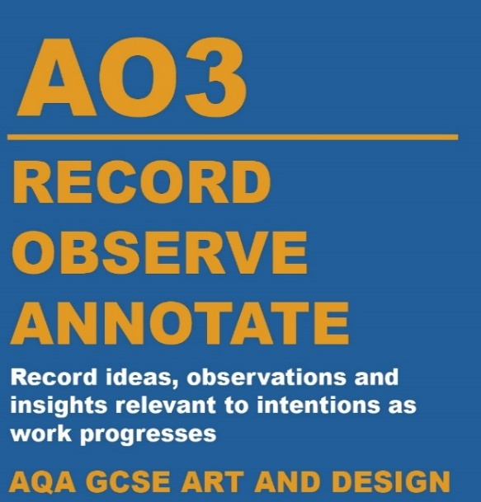
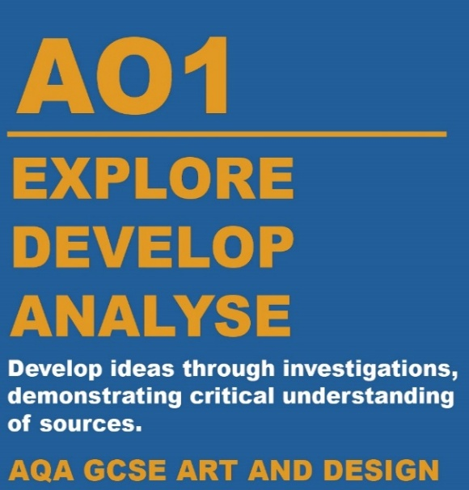
Assessment Objective 3 is about recording your ideas, observations, and insights in visual, written, or other forms. You should work from a variety of experiences and sources, as each one can inspire different directions for your project. Reflect regularly on your progress, considering what you've achieved and what you plan to do next.
Your understanding and intentions should be clear in how you use materials and techniques, and in how your ideas develop. Show that you've thought carefully about your choices and how they relate to your theme.
Make sure to reflect on your creative process, including your selection of media and contextual sources. Demonstrate your understanding of formal elements in both your own work and that of others, and consider how your ideas could be developed further in response to the set theme or brief.

Assessment Objective 1 is about developing and refining ideas from an initial starting point through to a final outcome. This process involves using mood boards, mind maps, sketches, and studies, while exploring the work of artists, designers, and craftspeople relevant to your theme.
It’s important to go beyond simply collecting facts. You should analyse the work you research and think critically about how it connects to your own ideas, then use this understanding to shape your creative decisions in a personal and meaningful way.

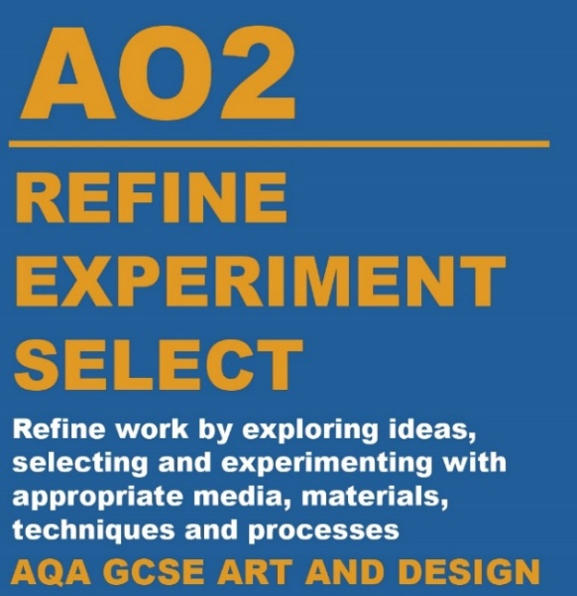
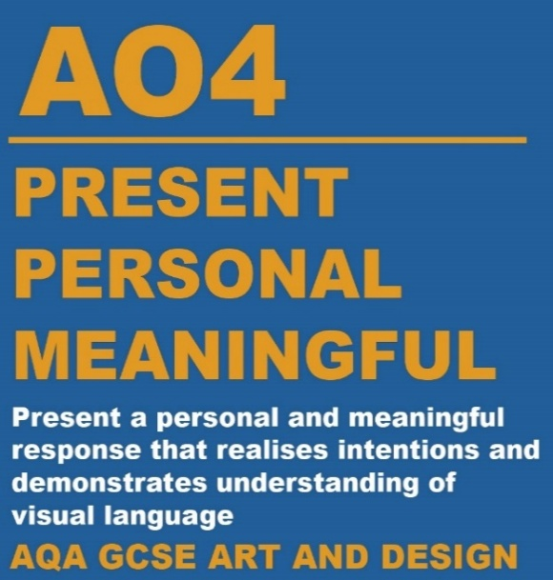
Assessment Objective 4 is about presenting a personal, informed, and meaningful response from your initial research to your final piece. You need to show a clear understanding of the theme and how artists, designers, or craftspeople work, using this knowledge to shape your own creative outcomes.
Your response should reflect thoughtful choices in source material and media, with clear connections between your work and the contextual sources you've explored. Record your ideas as they develop, showing how they lead to your final piece.
Organise your project so that the journey from your starting point to your final outcome is clear. Your work should demonstrate how your ideas have evolved and how you've applied your understanding of art and design throughout the process.

Assessment Objective 2 is about refining your ideas by experimenting with materials, techniques, and processes. Your choices should be informed by your understanding of how artists and designers use different materials. Through hands-on exploration, you’ll discover what works best for your intentions and develop your technical skills. You don’t need to use every method you try, but your final piece should clearly link to your practical studies. It’s important to show evidence of experimentation, so present your samples and tests clearly in your sketchbook, journal, or on mounted sheets.
Make sure to explain your creative decisions. Show how and why you selected certain materials or techniques, and use annotations to highlight connections between your work and the artists you’ve studied.

