Year 10 End of Semester 2 - Mock Exams
Below is the full English GCSE course. In the End of Semester 2 Mock Exams, Year 10 students will be sitting:
- A mock exam of Literature Paper 2 (2 hours, 15 minutes) and
- A Section B from a Language Paper 1 (45 minutes) in which they will be asked to write a speech.
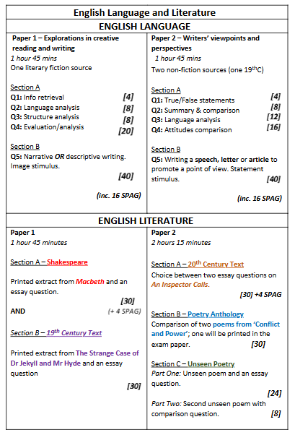

What they are being assessed on:
Literature Paper 2
Section A – 20th Century Text
- A choice of two questions on An Inspector Calls – students answer one question. The questions will be based on key characters and key themes.

Section B – Poetry Anthology
- A theme comparison question between one printed poem from their anthology and another poem from the anthology, of their choice. The question will be based around a theme, such as the effects of conflict.

Section C – Unseen Poetry
- Two questions on unseen poetry. The first question will ask them to write about how the poet presents ideas on a topic. Topics on previous exams have been aging, childhood, relationships and seasons. The second question will give them another poem and will ask them to compare the methods the poets use.

Language Paper 2
- Section B – Writing task
In the real exam, students could be asked to write a speech, an article or a letter. In this mock, students will be tasked with writing a speech. The purpose of their written piece should be to present a perspective or a viewpoint on the topic in the question.

Students in Year 10 have studied the entirety of An Inspector Calls and have been revising this through their Morning Meeting sessions. They have studied approximately half of the poems in their anthology (depending on which class they are in), and the chosen mock paper will include one of these. The topic of Unseen Poetry has been covered in Morning Meetings also.
How they will be graded:
The Literature Paper 2 is worth a maximum of 96 marks. Students will receive a mark, and an approximate grade.
The writing task from Language Paper 2 is worth a maximum of 40 marks. Students will receive a mark and an approximate grade.
Papers will be moderated within the department.

Revision
Literature Paper 2
Section A: Students should revise the following for An Inspector Calls:
- The plot and sequence of events in the play
- All of the characters in An Inspector Calls including key quotations:
- Arthur Birling, Sybil Birling, Sheila Birling, Eric Birling, Gerald Croft and Inspector Goole.
- The contextual factors surrounding the play, both when it was set and when it was written.
Word Revolution words including:
- Capitalism
- Socialism
- Elitism
- Individualism
- Patriarchal
All students have been given a Knowledge Organiser in Morning Meeting which includes information on all of these areas. Other revision resources can be found here:
https://www.bbc.co.uk/bitesize/topics/zqxc7hv

Section B: Students should revise the following for Anthology Poetry:
- Bayonet Charge
- Exposure
- Remains
- Poppies
- Charge of the Light Brigade
- War Photographer
Students need to know what the main themes are within each of the poems and learn key quotations. They need to be able to confidently comment on how the poet demonstrates the theme using language and structure.
All students were given copies of these poems at the beginning of Year 10 and annotated them in lessons. An additional resource can be found here:
https://thebicesterschool.org.uk/wp-content/uploads/2017/02/Poetry-Support-Booklet.pdf

Section C: Students should revise the following for Unseen Poetry
The acronym TWIST as an approach to analysing the poem:

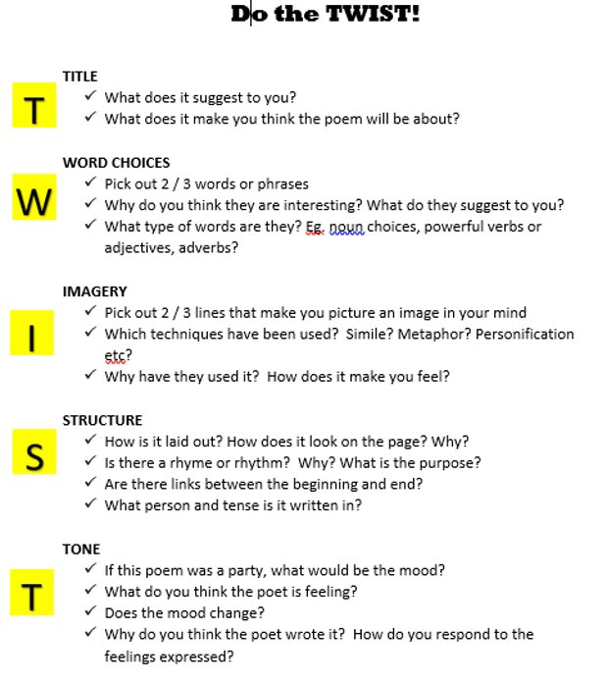
Students need to know what each of the following language techniques are and be able to comment on their effect in a poem:
- Similes
- Metaphors
- Personification
- Enjambment / caesura
- Semantic field
- Adjectives and verbs/adverbs
- Pathetic fallacy

A collection of poems from past papers are attached here:
https://laurawebbcpd.com/wp-content/uploads/2024/02/unseen-poetry-booklet-generic.pdf

Language Paper 2 Section B (Writing)
Students should revise the form of an speech and practice planning for a range of different tasks such as:
‘Education is not just about which school you go to, or which qualifications you gain; it is also about what you learn from your experiences outside of school.’ Write a speech for a school assembly to explain what you think makes a good education.

‘Cars are convenient, comfortable and save time. However, we need to use them less by making public transport such as trains, trams and buses cheaper, more reliable and easier to access.’ Write a speech to be given at a meeting of your local council in which you argue your point of view on this statement.

In preparation, students could plan one of the above questions using this structure and the language techniques.
Paragraph One: Introduce your topic, – use emotive language and appeal to readers’ sense of empathy. Remember – engaging opening!
Paragraph Two: Use some facts and figures and develop your point of view further.
Paragraph Three: What would someone who had a different opinion to you say? Explain their points but now undermine them.
Paragraph Four: Go back to your opinion: use some anecdotes, your own experiences or expert opinion to show the advantages of your point of view.
Paragraph Five: End by proposing a solution, or a way forward. What do you want the audience to DO now?

Students have been taught the following techniques to use when writing to persuade, argue or present a point of view:
D- Direct address
A – Arguing the counter point, alliteration
F - Facts
O – Opinions, other voices
R – Rhetorical questions
E – Emotive language
S - Statistics
T – Tripling

