Year 10 GCSE RS Summer Exam 2025
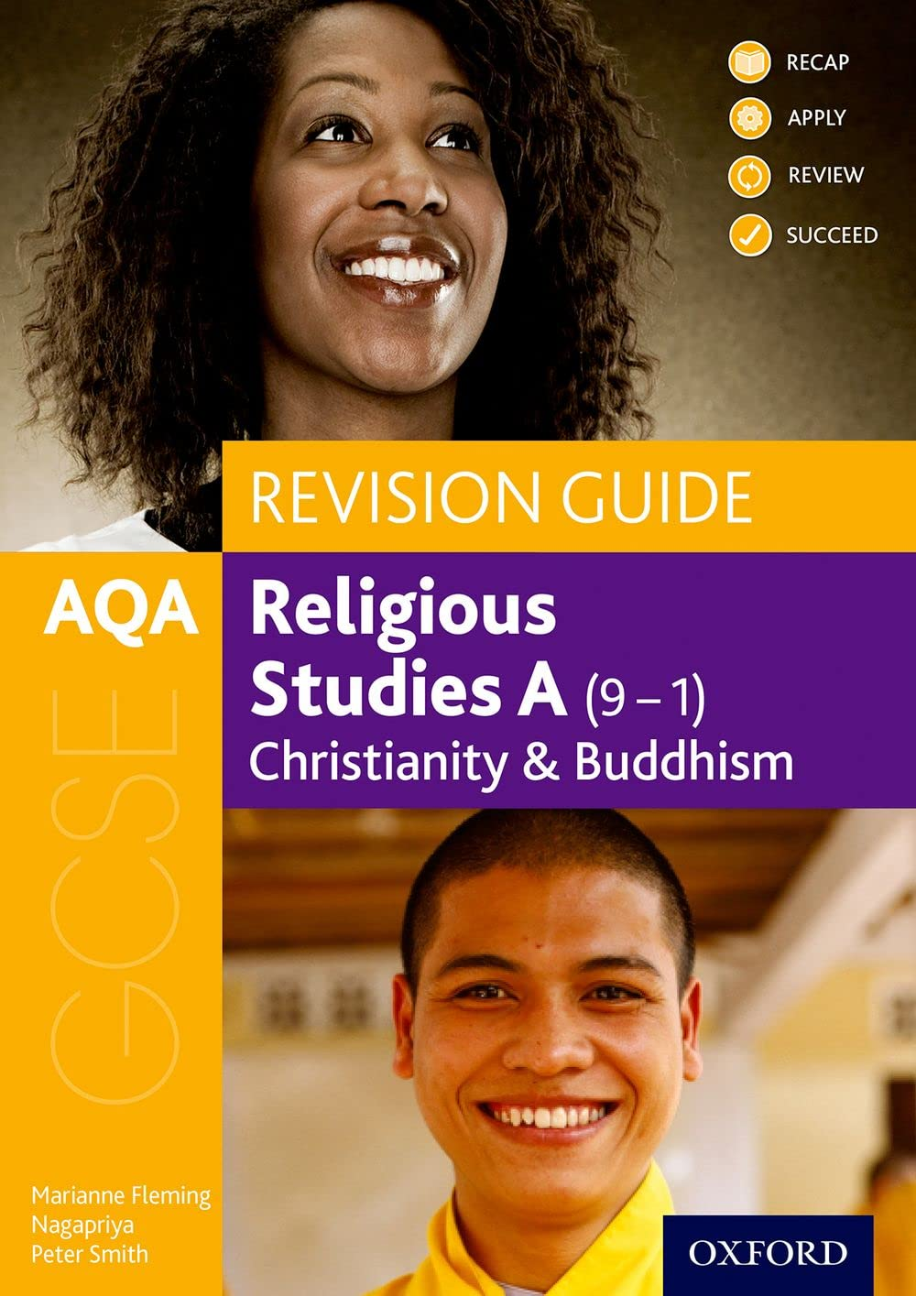
Themes Paper Revision
AQA Revision Guide (purchase from Amazon)
Title: AQA GCSE Religious Studies A: Christianity and Buddhism Revision Guide:(GCSE Religious Studies for AQA)

Relationships  and Families | Topic | Website / Resources Link
 | Entire Topic | Ben Wardle goes through the entire topic in 50 minutes!  https://www.youtube.com/watch?v=S8kMjD7MC-g
 | Religious teachings about general attitudes to sexual relationships and  Homosexuality and sexual relationships before and outside marriage | Page 84 and 85 Revision Guide
 | Procreation | https://www.bbc.co.uk/bitesize/topics/zg8b7v4/watch/zvwywsg
 | Contraception and family planning | Page 86 Revision Guide
 | Religious teachings about Marriage, Divorce and remarriage | Page 87 and 88 Revision Guide  https://www.bbc.co.uk/bitesize/topics/zg8b7v4/watch/zqfjfdm  Video
 | Religious teachings about nature of family | Page 89 Revision Guide
 | Religious teachings about Purpose of Family | Page 90 Revision Guide  https://www.bbc.co.uk/bitesize/topics/zg8b7v4/watch/zmv7vj6  Video
 | Religious beliefs about Gender Equality | Page 91 Revision Guide  Vicar of Dibley Season 1 Episode 1 gives an overview of different Christian attitudes to women vicars  https://www.channel5.com/show/comedy-classic-the-vicar-of-dibley
Religion  and  Life | Topic | Website / Resource Link
 | Entire Topic | Ben Wardle goes through the entire topic in 50 minutes!  https://www.youtube.com/watch?v=ZtD9a7edtIg  Video
 | Origins of the Universe  Origins of Life  Religious views on these topics | Page 96 and 100 Revision Guide  https://www.bbc.co.uk/teach/class-clips-video/articles/zvfp382  Video  https://www.bbc.co.uk/teach/class-clips-video/articles/zmqdmfr  Video – Darwin and Evolution
 | Religious attitudes to Use and abuse of the environment  Pollution  Religious views on these topics | Page 97 and 98 Revision Guide
 | Use of Animals  Religious views on this topic | Page 99 Revision Guide  https://www.bbc.co.uk/teach/class-clips-video/articles/z6s6nrd  Video
 | Abortion  Religious views on this topic | Page 101 Revision Guide  https://www.bbc.co.uk/teach/class-clips-video/articles/z4qkjhv  Video
 | Euthanasia  Religious views on this topic | Page 102 Revision Guide
 | Death and Afterlife  Religious views on this topic | Page 103 Revision Guide  https://www.bbc.co.uk/teach/class-clips-video/articles/zrfp382  Video

