Year 10 GCSE RS Summer Exam 2025
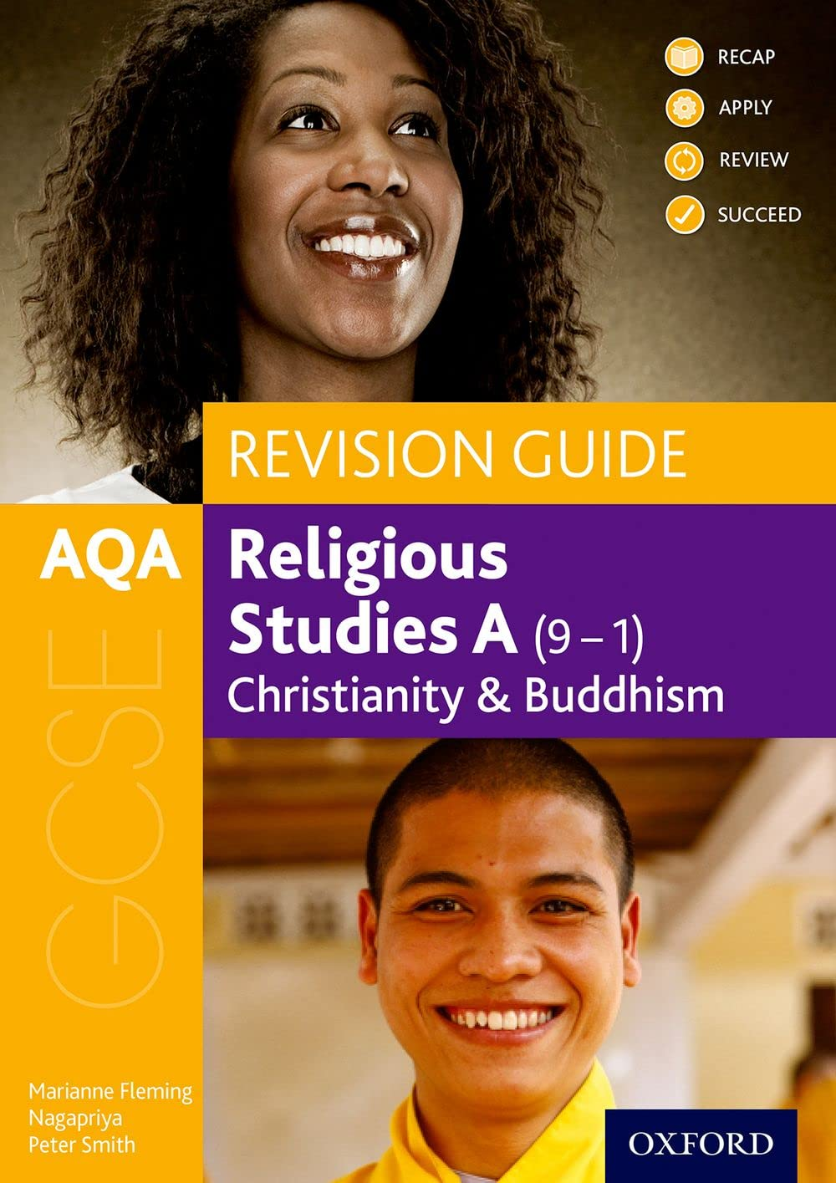
Christianity Paper Revision
AQA Revision Guide (purchase from Amazon)
Title: AQA GCSE Religious Studies A: Christianity and Buddhism Revision Guide:(GCSE Religious Studies for AQA)
Christian beliefs

Christian Beliefs | Topic | Website / Resources Link
 | Entire Topic | Ben Wardle goes through the entire topic in 1 hour and 20 minutes!  https://www.youtube.com/watch?v=edy52e-DZCg  Video
 | Nature of God | Page 12 and 13 Revision Guide  https://www.youtube.com/watch?app=desktop&v=aN9vSYVKfLU  Video Ben Wardle
 | Problem of evil | Website: https://www.bbc.co.uk/bitesize/guides/zv93rwx/revision/5  https://www.youtube.com/watch?v=VrOkSQ3y8mM  Video Ben Wardle
 | Trinity | Page 14 Revision Guide  Website: https://www.bbc.co.uk/bitesize/guides/zbj48mn/revision/2
 | Creation | Page 15 Revision Guide  https://www.bbc.co.uk/bitesize/guides/z683rwx/revision/1  Video
 | Incarnation | Page 16 Revision Guide  Website: https://www.bbc.co.uk/bitesize/guides/zbj48mn/revision/7
 | Crucifixion | Page 90 Revision Guide  Website:  https://www.bbc.co.uk/bitesize/guides/z43f3k7/revision/5
 | Resurrection | Page 18 and 19 Revision Guide  Website:  https://www.bbc.co.uk/bitesize/articles/zsjjxg8#zfqq6rd  Video:https://www.youtube.com/watch?v=Wnbo2AmS3OI
 | Heaven and Hell | Page 20-21 Revision Guide  Website: https://www.bbc.co.uk/bitesize/guides/zwvymsg/revision/4  https://www.youtube.com/watch?v=EpQgwT6yk4E  Video
 | Sin and Salvation | Page 22 Revision Guide  https://www.youtube.com/watch?v=n0QUNRjlPnA  Video – Ben Wardle 16 minutes  https://www.youtube.com/watch?v=3hEuonBgfmk  AQA video
 | Salvation and Atonement | Page 23 Revision Guide
Christian Practices | Topic | Website / Resource Link
 | Entire Topic | Ben Wardle goes through the entire topic in 1 hour and 34 minutes  https://www.youtube.com/watch?v=p25rGlGJBWc  Video
 | Worship | Page 28 Revision Guide  https://www.youtube.com/watch?v=E5-aKSrLXM4  https://www.bbc.co.uk/bitesize/topics/zjjdnk7/watch/zdpkh4j  Video
 | Prayer | Page 29 Revision Guide  https://www.youtube.com/watch?v=bS5BFgQWRU4  Video
 | Sacraments baptism | Page 30 Revision Guide  https://www.youtube.com/watch?v=uRymbCJmbYk  Video
 | Eucharist | Page 31 and 32 Revision Guide  https://www.youtube.com/watch?v=fQq9WDliZGc  Video
 | Celebrating festivals | Page 34 Revision Guide  Video on Easter  https://www.youtube.com/watch?v=MK2o-mhBfuc  Video on Christmas  https://www.youtube.com/watch?v=IO6hjEjPxoM
 | The role of the Church in the local community: Food banks | Page 35 Revision Guide  https://www.youtube.com/watch?v=5qLeGJ8cMKw  https://www.youtube.com/watch?v=1TWsQZN87sI  AQA video
 | The role of the Church in the local community: Street Pastors | Page 36 Revision Guide  Website: https://cte.org.uk/mission/page/mission-and-street-pastors-and-street-angels/
 | Mission and evangelism | Page 37 Revision Guide  https://www.youtube.com/watch?v=EEmmzyM22ms  Video
 | Church growth | Page 38 Revision Guide  Website: https://www.bbc.co.uk/bitesize/guides/znqck2p/revision/8
 | The importance of the worldwide Church | Page 39 Revision Guide  Website: https://www.bbc.co.uk/bitesize/guides/znqck2p/revision/9
 | Christian persecution | Page 40 Revision Guide  Website: https://www.bbc.co.uk/bitesize/guides/z8m24qt/revision/
 | The Church’s response to world poverty | Page 41 Revision Guide

