Year 8 Assessment
Students will be asked to write a description of an image that they will be given in the assessment. Our recent study in lesson has been a range of writing styles, of which description has been one of them. We will be using our own KS3 mark scheme which will then be moderated in department time.
GO MASSIVE
- Imagery
- Smilies
- Metaphors
- Using the five senses
- Lists
- Emotive language
- Personification

Revision:
To revise students could read a range of examples of descriptions in novels that they enjoy. They could practise their own descriptive paragraphs using any image, it could be an image of some mountains, a busy train station, an abandoned caste to name a few.
They could also use their knowledge organisers and practice writing the word revolution words into sentences.
Students could use the image and prompts below to use a practice.
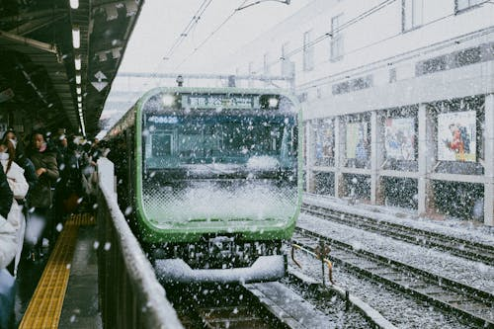
What sounds could you hear?
What simile could you use to describe the snow?
What colours are in the image? Can you compare them to something else?
How are the crowds moving?
What might you overhear the people saying to each other?
What time of day is it?

Revision tasks:
- Write four paragraphs of a description of an image of your choosing or use the image and prompts above
- Write a list of all punctuation and write an example sentence
- Using the five senses write a descriptive sentence for each
- Read one extract from an autobiography or biography
There are also helpful resources that have quizzes and videos on BBC Bitesize that has information and activities for students:
https://www.bbc.co.uk/bitesize/articles/zhwkkty#zvhxxbk
The below website gives a whole host of inspiring images that could be used to practice descriptive writing:
https://www.onceuponapicture.co.uk/

