Physics Required Practical – Refraction

Aim: What happens to the direction of light (reflection and refraction) after hitting the surface of different materials?

PRACTICAL SKILLS:
Good: I can take measurements and record them to the accuracy of the measuring instrument.
Great: Describe and explain whether your results match the theory.
Even Better: Identify the largest source of uncertainty and suggest how to reduce it.
Purple zone: Apply your knowledge t an exam question.

EQUIPMENT You have access to the following:

- ray box
- suitable power supply
- a slit and lens that fit the ray box and can be used to make a narrow ray
- two rectangular transparent blocks of different materials eg glass, Perspex
- 30 cm ruler
- protractor
- sheets of plain A3 paper.

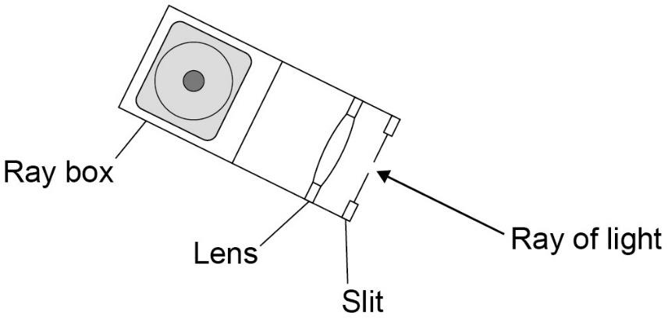

PROCEEDURE

Read these instructions carefully before you start work .

- Set up the ray box, slit and lens so that a narrow ray of light
is produced. Then darken the room.

- The ray box will get hot – be careful when you move it.
N
Switch it off when you don’t need it.

- Place the ruler near the middle of the A3 paper and draw
a straight line parallel to its long side.

- Use the protractor to draw a second line at right angles
to this line.
Label this line with an ‘N’ for ‘normal’.

- Place the longest side of a transparent block against the first line, with the largest face of the block on the paper.
The normal should be near the middle of the block.

- Draw around the transparent block. Be careful not to move it.

- Use the ray box to direct a ray of light at the point where the normal meets the block.
This is called the ‘incident ray’.

- The angle between the normal and the incident ray is called ‘the angle of incidence’.
Move the ray box or paper to change the angle of incidence. Do this until you see;
- a clear ray reflected from the surface of the block
- another clear ray leaving the opposite face of the block.

You will probably have to do this with the room darkened.

N
X
X
X
X
- Mark the path of the incident ray with a cross. If the ray is wide, make sure the centre of the cross is in the centre of the ray.

- Mark the path of the reflected ray with another cross.

- Mark the path of the ray that leaves the block (the transmitted ray) with two crosses. One cross needs to be near the block and the other cross further away.

- Switch on the room lights. Switch off the ray box and remove the block.

- Draw the incident ray by drawing a line through your first cross to the point where the normal meets the block.

- Draw the reflected ray by drawing a line through your second cross to the point where the normal meets the block.

- Draw the transmitted ray by drawing a line through the two crosses on the other side of the block to that side of the block. Label this point with a ‘P’.

- Draw a line that represents the path of the transmitted ray through the block.
Do this by drawing a line from point P to the point where the normal meets the block.
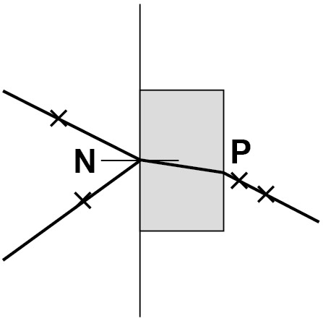

- Use the protractor to measure:
- the angle between the incident ray and normal − this is the angle of incidence
- the angle between the reflected ray and normal − this is the angle of reflection
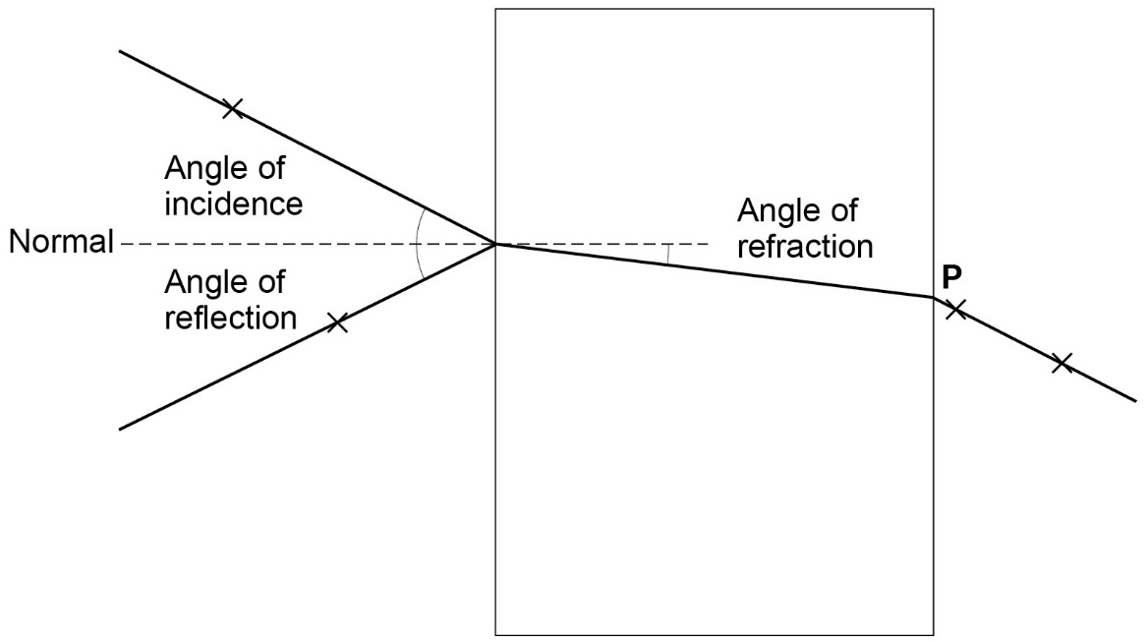
- the angle between the ray inside the block and the normal − this is the angle of refraction.

Draw a table like the one below and record your measurements.

Angle of incidence in degrees | First block |  | Second block
Angle of incidence in degrees | Angle of reflection in degrees | Angle of refraction in degrees | Angle of reflection in degrees | Angle of refraction in degrees

- Now repeat steps 3‒17 for the other transparent block.
Place the other block on the A3 paper.

- Line up the long side of the block as before.

- If the block is not the same size as the first one, carefully draw around it without moving it.

- Use your ray box to send in an incident ray along the same line as before. Again you may have to work in a darkened room.

- Look at the directions of the reflected and transmitted rays.

- If they are not the same as before, mark their paths using crosses.

- Remove the block, switch off the ray box, and switch on the room lights.

- Draw in the reflected and refracted rays.

- Measure the angle of reflection and the angle of refraction. Record them in your table.

EVALUATION

- Physics theory suggests that the angles of reflection should be the same, but the angles of refraction should be different. How well do your results support this theory?

- What was the biggest source of uncertainty in your experiment?

- Suggest how you could reduce this uncertainty.

Application / purple zone

A student investigated the refraction of light as it passes into and out of a clear plastic block.

Diagram 1 shows the apparatus the student used. Diagram 1

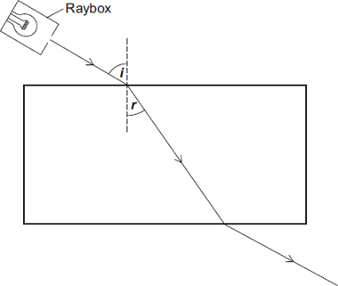

(a) Diagram 2 shows the same apparatus. Use a ruler to draw on Diagram 2 the path of the light ray. Diagram 2

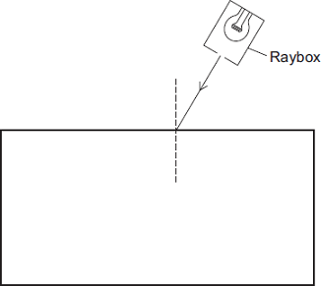

(2)

(b) The student measured the angle of refraction (r) for different angles of incidence (i) for light entering the plastic block.

The results are shown in Graph 1.

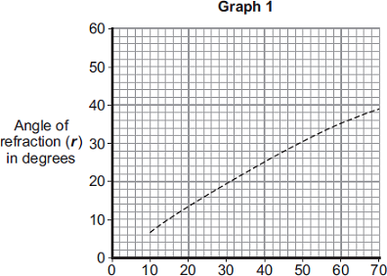

Angle of incidence (i) in degrees

(i) What two conclusions can be made about the relationship between the angle of incidence and the angle of refraction from Graph 1?

1 ............................................................................................................

...............................................................................................................

2 .............................................................................................................

................................................................................................................

(2)

(ii) Graph 2 shows the student’s results for light passing from air into plastic. The graph also shows the results for light passing from air into water.

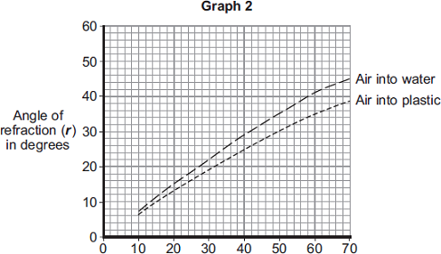

Angle of incidence (i) in degrees

How does the refraction of light passing from air into water compare to the refraction of light passing from air into plastic?

...............................................................................................................

...............................................................................................................

(1)

(c) In some countries people are too poor to pay for electricity. Some people living in small houses with no natural light are using bottles filled with water instead of light bulbs.

The bottles are fitted into small holes in the roof of the house. Sunlight refracts as it passes into and out of the bottle, causing light to spread into the room. This simple device gives about the same amount of light as a 50 W light bulb.

Diagram 3

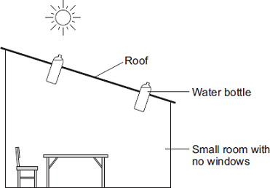

(i) Suggest one way this simple device can help improve the lives of the people using it.

...............................................................................................................

...............................................................................................................

(1)

(ii) The increasing use of energy resources to generate electricity within developed countries has ethical implications.

Suggest one ethical implication.

...............................................................................................................

...............................................................................................................

(1)

(Total 7 marks)

