Physics Required Practical – Resistance in wires

Aim: Investigate the effect of length of wire on resistance

PRACTICAL SKILLS:
Good: I can create a results table for my experiment.
Good: I can record all my data to the accuracy of the measuring instrument and calculate resistance.
Good: I can draw graph axis and label them with the correct titles and units.
Great: I can use evenly spaced scales on my graph axis so that my results cover at least half of each axis.
Even Better: I can draw a suitable line of best through my data so that it has an even number of points on each side.
Good: I can describe the trend shown by my graph.
Good: I can quote two sets of data from my graph as evidence for my conclusion.
Great: I can create a scientific explanation to my conclusion.
Purple zone: I can evaluate the repeatability, reliability, range and intervals used in my investigation and suggest how I could make improvements.

EQUIPMENT
You have access to the following:
- 1 x ammeter
- 1 x voltmeter
- 1 length of wire (1 m) on a board
- 6 x wires
- 2 x crocodile clips
- 1 x power supply set to 2V

DIAGRAM

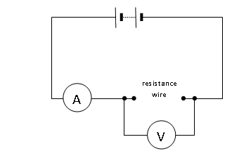

PROCEEDURE
You should read these instructions carefully before you start work.
- Set the circuit as shown in the circuit diagram, with the crocodile clips at each end of the wire at first (wire length = 1m).
- Set the power pack to 2V (Should have been done already) and switch it on.
- Record the measurements on the voltmeter and the ammeter screens in your table.
- Move the crocodile clips so the wire is 0.8m long and record the voltage and current at this new length.
- Repeat for 0.6m; 0.4m; and 0.2m.
- For each length calculate the resistance of the wire and record this in your table.

Repeat the whole experiment twice more.

ANAYLSIS
- Draw a graph of length of wire (x axis) against resistance (y axis) including a line of best fit.
- Create a PEE conclusion for your graph.

EVALUATION
- Do your results show that your experiment was repeatable? Use evidence to explain your answer.

- Does your graph show that your experiment was reliable? Use evidence to explain your answer.

- Do your results and graph show that the range of lengths used was sufficient to show a clear trend? Use evidence to explain your answer.

- Do your results and graph show that the intervals between each length used was sufficient to show differences in your dependent variable? Use evidence to explain your answer.

- Suggest an improvement to your investigation and explain why it will improve your experiment.
- Why might your line of best fit not go through the origin?

Beyond this experiment …

- a) How could you adapt your experiment to investigate how the thickness of a wire affects it’s resistance?

b) Predict what trend you would see between the thickness of a wire and it’s resistance. Explain your answer

