Physics Required Practical – Resistance series and parallel circuits

Aim: Investigate the effect of combining resistors in series and parallel

PRACTICAL SKILLS:
Good: I can record all my data to the accuracy of the measuring instrument and calculate resistance.
Great: I can analyse data to make informed predictions.
Even better: I can analyse data and formulate generic rules for calculating total resistance.
I can apply my knowledge to exam questions.
Ultra Challenge: I can relate my findings to springs in series and parallel.

EQUIPMENT
You have access to the following:
- a battery or suitable power supply
- ammeter or multimeter
- voltmeter or multimeter
- crocodile clips
- two 10Ω resistors
- connecting leads.

DIAGRAMS
Series Parallel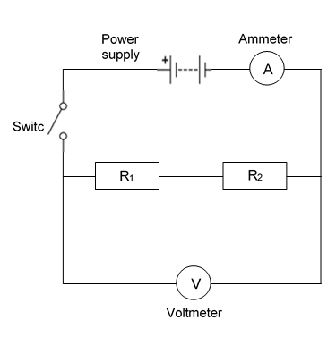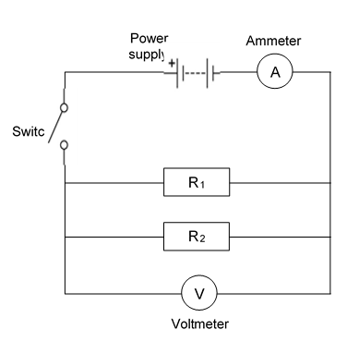

TASK 1 (Series)
- Connect the circuit for two resistors in series, as shown in the diagram.
- Switch on and record the readings on the ammeter and the voltmeter.
- Use these readings to calculate the total resistance of the circuit.

V / V | I / A | R / Ω

- With one single resistor in the circuit, the total resistance would be 10 ohms. What is the effect on the total resistance of adding another identical resistor in series?
……………………………………………………………………………………………………………………………………………………………………………………………………

- a. Predict what the resistance will be if had three resistors in series.
……………………………………………………………………………………………………………………………………………………………………………………………………

- Now use your equipment to find the resistance with three resistors in series.
V / V | I / A | R / Ω

- Was your prediction right? ……………………………………………………………………

- Analyse your results to create a generic rule and formula for calculating the total resistance when resistors are joined in series.
……………………………………………………………………………………………………………………………………………………………………………………………………
……………………………………………………………………………………………………………………………………………………………………………………………………

TASK 2 (Parallel)
- Now set up the circuit for two resistors in parallel (see diagram).
- Switch on and record the readings on the ammeter and the voltmeter.
- Use these readings to calculate the total resistance of the circuit.

V / V | I / A | R / Ω

- With one single resistor in the circuit, the total resistance would be 10 ohms. What is the effect on the total resistance of adding another identical resistor in parallel?
……………………………………………………………………………………………………………………………………………………………………………………………………

- a. Predict what the resistance will be if had three resistors in parallel.
……………………………………………………………………………………………………………………………………………………………………………………………………

- Now use your equipment to find the resistance with three resistors in parallel.
V / V | I / A | R / Ω

- Was your prediction right? ……………………………………………………………………

- Analyse your results to create a generic rule and formula for calculating the total resistance when resistors are joined in parallel.
……………………………………………………………………………………………………………………………………………………………………………………………………
……………………………………………………………………………………………………………………………………………………………………………………………………

Applying your knowledge

(a) A student is given three resistors of resistance 3.0 Ω, 4.0 Ω and 6.0 Ω respectively.

(i) Draw the arrangement, using all three resistors, which will give the largest resistance.

(ii) Calculate the resistance of the arrangement you have drawn.

(iii) Draw the arrangement, using all three resistors, which will give the smallest resistance.

(iv) Calculate the resistance of the arrangement you have drawn.

(5)

(b) The three resistors are now connected to a battery of emf 12 V and negligible internal resistance, as shown in Figure 1.

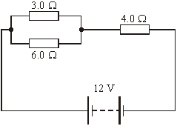

Figure 1

(i) Calculate the total resistance in the circuit.

.............................................................................................................

.............................................................................................................

(2)

(Total 7 marks)

Ultra Challenge (beyond this experiment …)
- Three identical resistors joined in parallel in an electrical circuit share the total current in the circuit. In a similar way, the three springs in the chest expander share the total force exerted. The spring constant of one spring is 400N/m.



By considering this similarity, determine the total force exerted on the chest expander when each spring is stretched by 0.25 m.

........................................................................................................................................................

........................................................................................................................................................

- When adding springs in series the total spring constant takes the same rule as when adding resistors in parallel. The formulas are shown below.
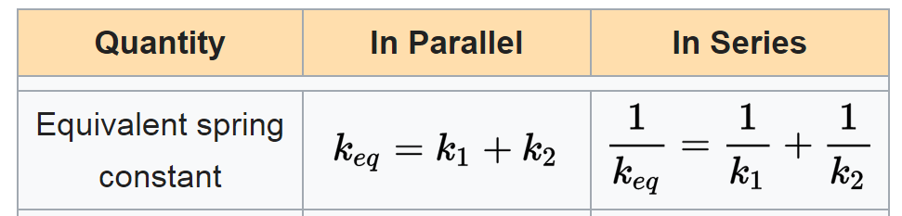

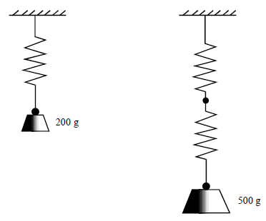

Figure 1 Figure 2

When a 200 g mass is suspended from a spring, as in Figure 1it is calculated that the spring constant is 56N/m. A spring identical to that in part (a) is joined to the lower end of the original one and a 500 g mass is suspended from the combination, as shown in Figure 2.

State the value of the new spring constant for this combination of two springs.

.........................................................................................................................

- When adding springs in series the total spring constant takes the same rule as when adding resistors in parallel. The formulas are shown below.
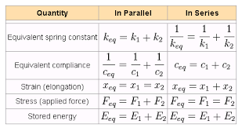

A load of 4.0 N is suspended from a parallel two-spring system as shown in the diagram.

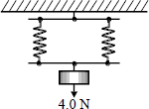

The spring constant of each spring is 20 N m^{–1}. The elastic energy, in J, stored in the system is
Hint:
What is Hooke’s Law equation?
What is the equation for the elastic energy stored by a spring?
 | A | 0.1
 | B | 0.2
 | C | 0.4
 | D | 0.8

