Physics Required Practical – Density
Aim: To measure the density of different objects
PRACTICAL SKILLS:
Good: Accurately take measurements and record them to the accuracy of the measuring instrument.
Great: Apply the density equation and calculate the density of different objects.
Even Better: Analyse results and compare them to the true values to determine what different objects are made from.
Ultra Challenge: Evaluate your experimental method and suggest improvements.

EQUIPMENT 1 (Regular shaped objects)

You have access to the following:
- 30 cm ruler marked off in mm
- digital balance
- regular shaped objects.

PROCEEDURE (You should read these instructions carefully before you start work).
- For each object measure the length, height and width. Record your results in the table.
- Calculate the volume of each object and record it in the table.
- Use the balance to measure the mass of each object. Record your results in the table.
- Calculate the density of your objects and record them in the table.

RESULTS:
OBJECT | Length / cm | Width / cm | Height / cm | Volume / cm³ | Mass / g | Density g/cm³

ANALYSIS:
Use the table below to identify the substance each object is made from.
Substance | Aluminium | Zinc | Iron | Copper | Gold
Density in g/cm³ | 2.7 | 7.1 | 7.9 | 8.9 | 19.3

EVALUATION (Ultra Challenge)
- What was the resolution of your length, height and width measurements?

- What was the biggest source of uncertainty in your experiment?

- Suggest how you could reduce this uncertainty.
EQUIPMENT 2 (Irregular shaped objects)

You have access to the following:
- digital balance
- displacement can and something to stand it on (eg a brick)
- various measuring cylinders
- beaker of water and an extra empty beaker
- paper towels
- cotton or thin string
- irregularly shaped objects.

PROCEEDURE (You should read these instructions carefully before you start work).
- Measure the mass of one of the irregular shaped objects and record it in the table.
- Place a displacement can on a brick. Put an empty beaker under the spout and fill the can with water. Water should be dripping from the spout.
- Wait until the water stops dripping. Then place a measuring cylinder under the spout instead of the beaker.
Choose the measuring cylinder you think will give the most precise reading.
- Tie the object to a piece of cotton. Very carefully lower it into the displacement can so that it is completely submerged.
Collect all of the water that comes out of the spout in the measuring cylinder.
- Measure and record the volume of the collected water in your table. This volume is equal to the volume of the object.
- Calculate and record the density of the object.
- Repeat steps 1‒6 for some other objects.
Remember to refill the can each time.

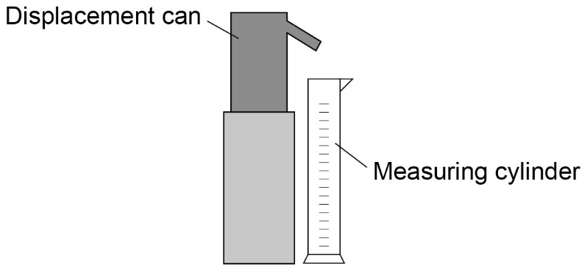

RESULTS:
OBJECT | Mass / g | Volume / cm³ | Density g/cm³

EVALUATION (Ultra Challenge)
- What was the resolution of your volume measurements?

- How could you find out if this experiment was repeatable?

- If you were to plot a graph of object against density what type of graph would you plot? Why?

EQUIPMENT 3 (Liquids)

You have access to the following:
- digital balance
- 250 ml beaker
- 100 ml measuring cylinder
- suitable liquid eg sugar solution.

PROCEEDURE (You should read these instructions carefully before you start work).
- Measure the mass of the empty beaker and record it in your table.
- Pour about 100 ml of liquid into the measuring cylinder. Measure and record the volume.
- Pour this liquid into the beaker. Measure and record the mass of the beaker and liquid.
- Calculate and record the mass of the liquid.
- Calculate the density of the liquid.

RESULTS

 | Mass of empty beaker / g | Mass of beaker and liquid / g | Mass of liquid/ g | Volume of liquid used / cm³ | Density g/cm³
TEST 1
TEST 2
TEST 3
AVERAGE

ANALYSIS:
The density of water is 1 g/cm³. Determine the mass of sugar per cm³ dissolved in the water. Assume the sugar does not affect the volume of the water.

EVALUATION (Ultra Challenge)
- What was the resolution of your mass measurements?

- How could you find out if this experiment was reproducible?

- What kind of error would exist in your results if the digital balance read 0.2g when nothing was on the balance? How could you solve this problem?

