Physics Required Practical - Acceleration

Aim: Investigate the effect of varying the force on the acceleration of an object of constant mass.

PRACTICAL SKILLS:
Good: Accurately take measurements and record them to the accuracy of the measuring instrument.
Draw an accurate results table including column headings with units
Great: Plot a graph of your results using evenly spaced scales.
Draw a suitable line of best through my data so that it has an even number of points on each side.
Even Better: Analyse your results and formulate a PEE conclusion.
Ultra challenge: Evaluate the repeatability, reproducibility, reliability, range and intervals used in my investigation and suggest how I could make improvements.

EQUIPMENT
You have access to the following:
- 1 x linear air track and gliders (including vacuum cleaner)
- 1 x bench pulley system including string
- 1 x small weight stack e.g. 1 N in steps of 0.2 N
- 1 x card
- two clamp stands, clamps and bosses
- two light gates, interface and computer software
- Blu-Tack to attach the weights to the glider.

DIAGRAM

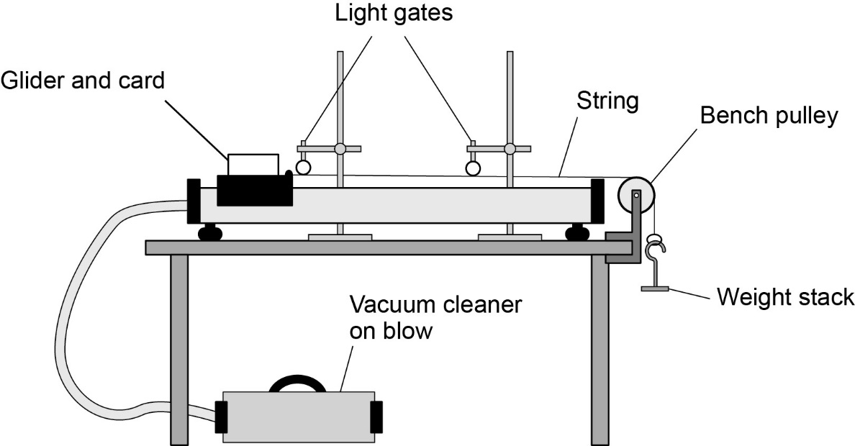

PROCEEDURE
You should read these instructions carefully before you start work.
The force in this experiment is provided by the weight stack.
- Attach the full weight stack (1 N) to the end of the string.

- Position the glider at the end of the air track furthest from the pulley.

- Switch on the software and vacuum.

- The glider should accelerate through the light gates towards the bench pulley. Record the acceleration in your table.

- Remove one weight (0.2 N) and (using the blue tack) attach that to the glider. This will keep the total mass constant. (The weight stack is being accelerated too.) Repeat steps 2-4 and record your results in your table.

- Repeat the experiment for a force of 0.8N; 0.6N; 0.4N; 0.2N. Remember to attach each weight to the glider as it is removed from the weight stack.

- Repeat the experiment three times and calculate a mean acceleration for each force.

ANAYLSIS
- Plot a graph of force (x axis) against average acceleration (y axis) including a line of best fit.
- Formulate a full PEE conclusion for your graph.

EVALUATION
- Do your results show that your experiment was repeatable? Use evidence to explain your answer.

- How could you see if your experiment was reproducible?

- Does your graph show that your experiment was reliable? Use evidence to explain your answer.

- Do your results and graph show that the range of resultant forces used was sufficient to show a clear trend? Use evidence to explain your answer.

- Do your results and graph show that the intervals between each resultant force used was sufficient to show differences in your dependent variable? Use evidence to explain your answer.

- Describe how you could adapt this experiment to investigate how (when under a constant force) the mass of an object affects it’s acceleration.

