Physics Required Practical – Measuring waves (ripple tank)
Aim: To measure the wavelength, frequency and velocity of a wave.
PRACTICAL SKILLS:
Good: I can take measurements and record them to the accuracy of the measuring instrument.
Great: I can apply the wave equation and calculate the average speed of the wave.
Even Better: I can identify sources of uncertainty and suggest how to reduce them.
Purple zone: I can analyse my experiment and suggest how it can be adapted to investigate a different variable.

EQUIPMENT You have access to the following:
- ripple tank plus accessories
- suitable low voltage power supply
- metre ruler.

PROCEEDURE (You should read these instructions carefully before you start work).
Setting it up:
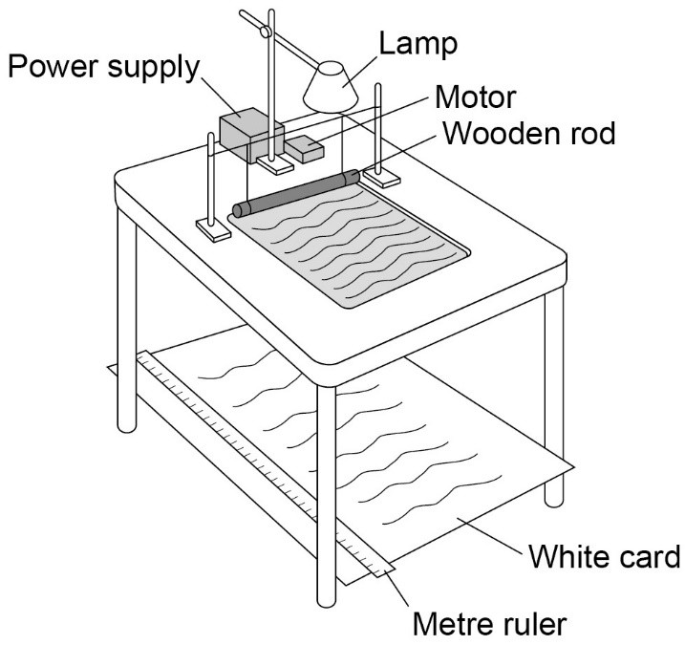
- Set up the ripple tank.
A large sheet of white card or paper needs to be on the floor under the tank.
- Pour water to a depth of about 5 mm into the tank.

- Adjust the height of the wooden rod so that it just touches the surface of the water.

- Switch on both the overhead lamp and the electric motor.

- Adjust the speed of the motor. Low frequency water waves need to be produced.

- Adjust the height of the lamp. The pattern needs to be clearly seen on the card on the floor.

Collecting Results:
- Place a metre ruler at right angles to the waves shown in the pattern on the card.
Measure across as many waves as possible. Then divide that length by the number of waves. This gives the wavelength of the waves.
 | Length measured / m | Number of waves | Wavelength / m
Test 1
Test 2
Test 3
Average

- Count the number of waves passing a point in the pattern over a given time (say 30 seconds).
Then divide the number of waves counted by 30. This gives the frequency of the waves.
 | Number of waves in 30 seconds | Frequency / Hz
Test 1
Test 2
Test 3
Average

- Calculate the average speed of the waves using the equation:
wave speed = frequency × wavelength

EVALUATION
- Were your results for wavelength precise? Use evidence to explain your answer.

- What was the biggest source of uncertainty in your experiment?

- Suggest how you could reduce this uncertainty.

- The waves close to the beach have different wave speeds to those in the deep ocean.
  - Suggest how the wave speed is affected by the depth of the water?

  - Suggest how you adapt this experiment to investigate how the depth of water affects the wave speed.

- Which method of measuring the speed of waves do you think was most accurate? Explain your answer.

