Physics Required Practical – Measuring waves (string)
Aim: To measure the wavelength, frequency and velocity of a wave.
PRACTICAL SKILLS:
Good: I can take measurements and record them to the accuracy of the measuring instrument.
Great: I can apply the wave equation and calculate the average speed of the wave.
Even Better: I can identify sources of uncertainty and suggest how to reduce them.
Purple zone: I can analyse my experiment and suggest how it can be adapted to investigate a different variable.

EQUIPMENT You have access to the following:
- vibration generator
- suitable power supply (variable frequency)
- suitable string or elasticated cord
- set of 100 g masses and hanger
- set of 10 g masses and hanger
- wooden bridge
- pulley on a clamp.

PROCEEDURE (You should read these instructions carefully before you start work).
Setting it up:
- Set up the apparatus as shown.

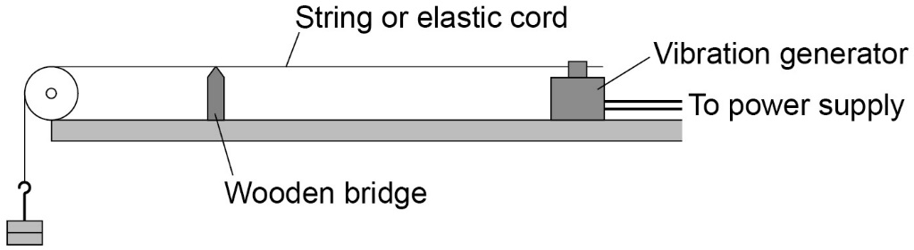

- Switch on the vibration generator. The string (or elasticated cord) should start to vibrate.
- A clear wave pattern needs to be seen. To do this, adjust the tension in the string or move the wooden bridge to adjust the length of the string.
The waves should look like they are stationary.

Collecting Results:
- Use a metre ruler to measure across as many half wavelengths as possible (a half wavelength is one loop).
In the diagram below you can see 4 half wavelengths.
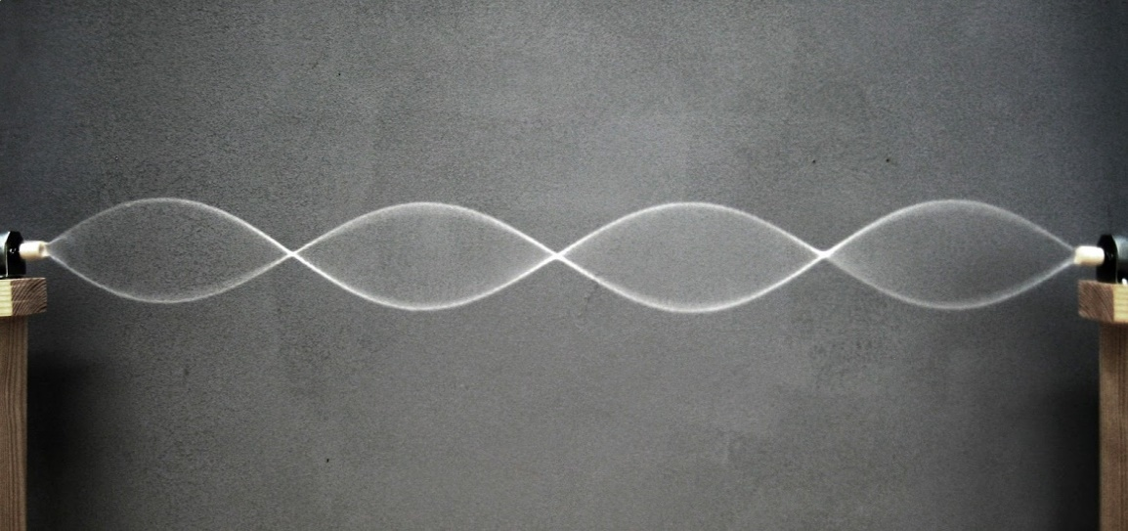

Then divide the total length by the number of half waves. Multiplying this number by two will give the wavelength.
 | Length measured / m | Number of half waves | Wavelength / m
Test 1
Test 2
Test 3
Average

- The frequency is the frequency of the power supply.

___________________________________________________________________________________________

- Calculate the average speed of the wave using the equation:
wave speed = frequency × wavelength

___________________________________________________________________________________________

EVALUATION
- Were your results for wavelength precise? Use evidence to explain your answer.

- What was the biggest source of uncertainty in your experiment?

- Suggest how you could reduce this uncertainty.

- The strings on a guitar all have different wave speeds. If you have a chance to look at a guitar or violin you can see that each string is a different thickness, which allows them to produce a different range of notes.
  - Suggest how the wave speed is affected by the thickness of the wire?

  - Suggest how you adapt this experiment to investigate how the thickness in the string affects the wave speed.

- Which method of measuring the speed of waves do you think was most accurate? Explain your answer.

