Year 10 Internal Exams Maths Revision Guide
In order to best prepare for your upcoming examinations you should use the resources outlined below:

- The interactive revision checklist:
Students should identify areas in mathematics using the checklist provided. Each topic area is outlined in the first column, there is then a number with a link. The link will take you to an explanatory video on the ‘corbett maths’ website. When you have watched the video you should tick the matching box. The website then has a textbook exercise and exam questions available for you to complete along with solutions. Once you have complete the exercise you can then tick to say that you understand the topic. An example of the checklist is included below:
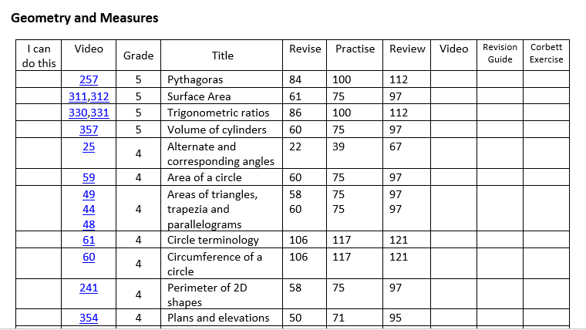
The checklist also guides students to the correct page in the revision guide to read notes and complete exercises on the topics outlined. Students who do not have revision guides can purchase them via parent pay for £3.99 and then collect them from Mr. Macrow’s office.

Students in sets 4 and 5 should use the ‘foundation checklist’, students in set 3 should use the ‘intermediate checklist’ and students in sets 1 and 2 should use the ‘higher checklist’.

These checklists can be found on the school’s website under year 11 revision resources or via the google classroom.

Students can access the google classroom using the instructions below:
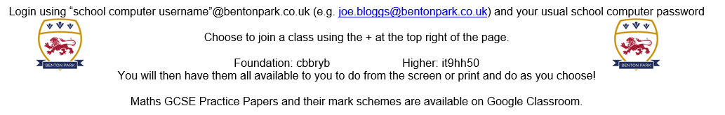

- Past Papers
The google classroom is also complete with 9 sets of 3 practice papers. Students can complete these papers in addition to their fortnightly homework papers in order to maximise their revision.

- ‘5 – a – day’
Students can also make use of the ‘5 – a – day’ resources on the corbett maths website. These can be found using the link below, which is again posted in the year 11 revision resources of the school’s website.

https://corbettmaths.com/5-a-day/gcse/

Completing 5 questions each day will really support you in your revision and preparation for your internal examinations.

The best way to revise maths is to do maths! By making use of the resources provided will support your revision in the lead up to your exams.

